Media Relations Information for 07/10/2012
Public Relations Officer – Sgt. John Krueger
Office: 281-842-3161

LPPD files warrants against seven pellet gun vandals

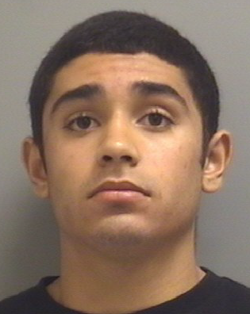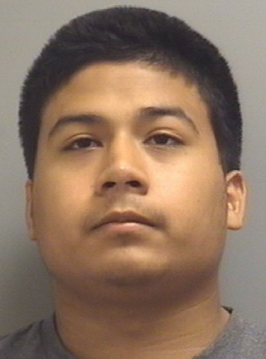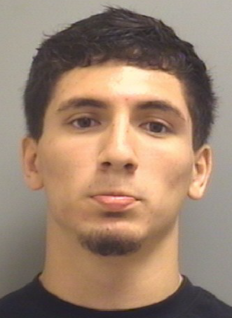
Marc Anthony Gonzalez Nicholas Iser Lara Manuel Luther Camacho Justyn Anthony Vela

Rolando Elias Perez
H/M 11/07/1993

PHOTO NOT AVAILABLE

Juvenile Male #2

PHOTO WITHHELD

Juvenile Male #1

PHOTO WITHHELD

On July 9th, 2012, La Porte Police investigators filed Criminal Mischief warrants against five adult and two juvenile males, closing a total of 17 vandalism cases. Each of the offenses was related to a string of broken vehicle windows which had been shot out by way of pellet guns in late March. Details involved the group initially attempting to set off homemade explosives within the front yards of know female acquaintances. When the devices failed to detonate, the suspects retrieved pellet guns and shot out several vehicle windows at the original residences of intention, as well as many others throughout La Porte’s Fairmont West subdivision. The suspects then completed a repeat performance within the same subdivision the following night.

As a result of these offenses, and comprehensive investigative research by LPPD detectives along with investigators from the La Porte Fire Marshall’s Office, Class A Misdemeanor Charges, with 3 counts each for Criminal Mischief, were filed on Marc Anthony Gonzalez (H/M - 09/29/1994), Rolando Elias Perez (H/M - 11/07/1993), Manuel Luther Camacho (H/M - 09/19/1994), Nicholas Iser Lara (H/M - 11/07/1994), and Justyn Anthony Vela (H/M - 09/11/1994). The pair of juvenile males were also charged with similar offenses.

To aid the prosecutorial process, the Harris County District Attorney’s Office elected to specifically focus on the three Criminal Mischief cases which had damage amounts totaling in excess of $500.00 each. Nevertheless, the listed males were all tied to the series of vandalism and, under the Texas Penal Code, will face the possibility of a $4000 fine and/or as much as a year in jail. Charges are still pending regarding the original explosive devices. The La Porte Fire Marshall’s Office is currently pursuing those cases.

