Media Relations Information for 08/22/2012
Public Relations Officer – Sgt. John Krueger
Office: 281-842-3161

LPPD’s Summer Safety Camps encourage La Porte youth

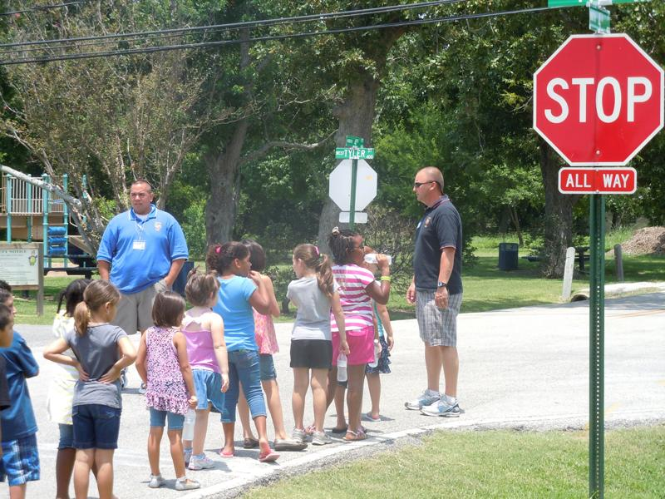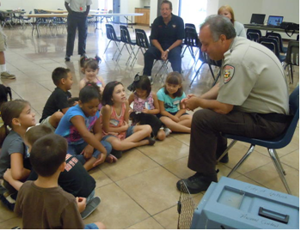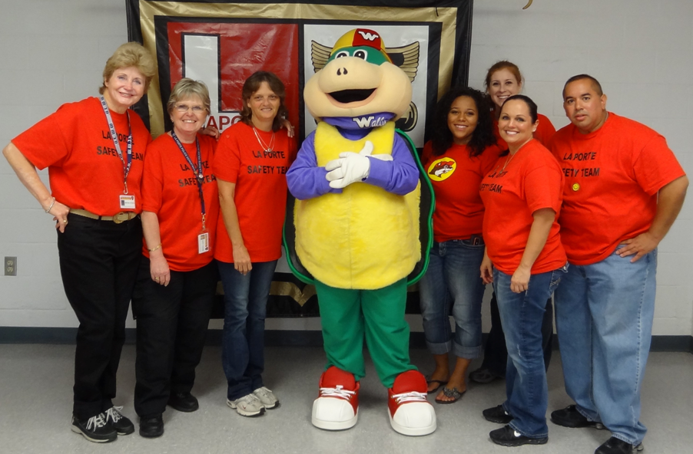
Summer Camps involved Officers teaching pedestrian safety, Animal Control discussing animal awareness and wellbeing, while area Volunteers and LEPC’s Wally Wise proved invaluable as well.

The La Porte Police Department recently completed their last of four youth Summer Safety Camps. From Police Officers, Animal Control Specialists, and Office of Emergency Management representatives, to citizen volunteers primarily from the La Porte Citizen’s Police Academy Alumni Association (LPCPAAA), numerous adults from the La Porte community gave of their time and expertise in an effort to educate area youth on topics such as water safety and “what children should do if they find a gun.” The combined endeavor between public servants and local volunteers was what La Porte Emergency Management Specialist Kristin Gauthier appropriately labeled “another example of the support and dedication continually displayed by La Porte’s many volunteers.”
The four Camps, spanning from the end of July to the middle of August, covered a great many topics such as Animal Safety, Stranger Danger, Internet awareness, Pedestrian practices, Seat Belt wearing, Fire prevention and reaction, Emergency Management, Child Safety Seat checks, Water precautions, Bicycle Safety, and much more. The camps were fully funded, including city staff time, through a combination of private corporate donations and the Harris County Child Safety Fund.
Over the course of the program children were discovered to have proudly shared their experiences with others, both inside and outside the community. This was recognized by one of the Camp’s adult volunteers who expressed “Testimonies of children are the best evidence to other children about whether something is important and worth their time, so the Safety Camps appeared to be a big win in the eyes of these kids. They are going to remember these lessons for some time.”
For more information on how you can volunteer with any of La Porte’s emergency services, or for details on LPPD’s youth Summer Safety Camps, please contact the agency’s Support Services Division at 281-842-3171.

