Media Relations Information for 05/01/2012
Public Relations Officer – Sgt. John Krueger
Office: 281-842-3161

La Porte Police Department’s Youth Explorers place well in State competition

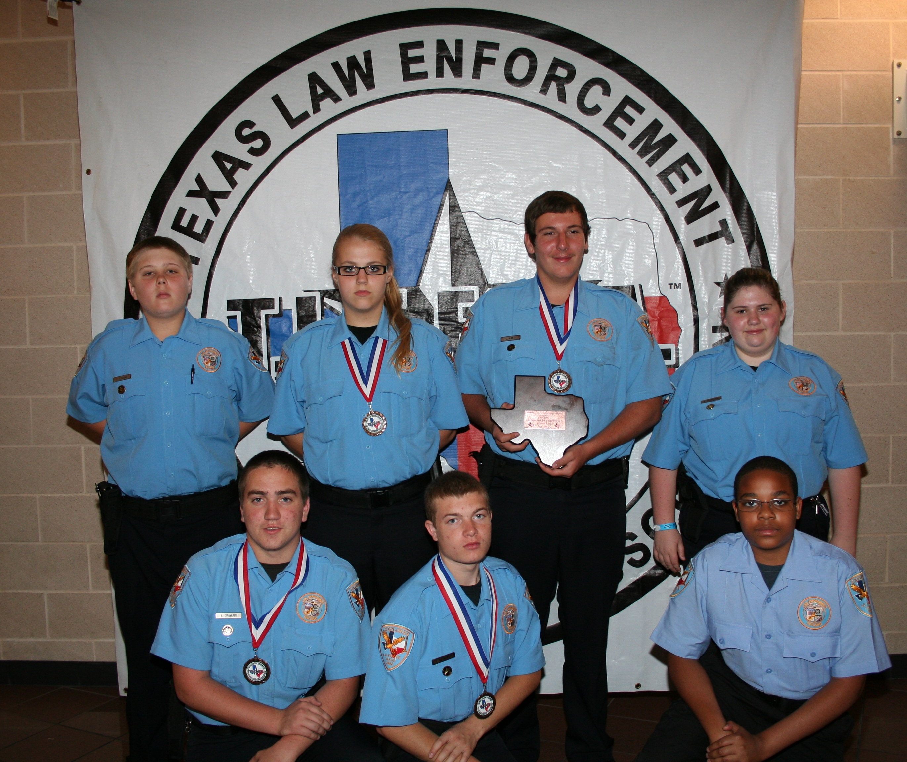
Members of La Porte PD’s Explorer program proudly display event awards

During the final weekend in April 2012, La Porte PD’s youth Explorer post participated in the Texas Law Enforcement Explorer Advisor Association’s (TLEEAA) annual State Explorer competition. This year’s 2012 State competition was hosted in Waxahachie, Texas with a total of 126 teams competing. A total of 7 La Porte Explorers participated in this year’s event and the team members were accompanied by three sworn Learning for Life advisors (LPPD Officers R. Gonzalez, C. Paige, and J. Dalton) and one Learning for Life civilian advisor (Viki Ferguson).

The contest consisted of 18 total scenarios where each Explorer team was given a number of randomly chosen scenarios in which to compete. Scenarios faced by La Porte’s members included a Burglary in progress, Bomb Notification, Officer Down, Motor Vehicle Accident investigation, White Collar Crime situation, Domestic Dispute, Felony traffic stop, and an unspecified call for police service. In the end, La Porte Explorers finished third, out of 126 teams, for the Bomb scenario assessment. This being only the second year in which La Porte’s Explorer Post competed, the third place finish in the Bomb notification scenario was hailed as a major milestone for the program and one of the highlights of the entire competition.

The most recent success of the La Porte Explorer group is quite encouraging, as the TLEEAA organization represents a thriving association which provides guidance, support, training, and competitive events for Law Enforcement Explorer Posts and Advisors throughout the entire State of Texas. Due to their level of personal and team dedication, LP Explorer successes are expected to expand even further. La Porte PD’s youth Explorers train every week and occasionally attend weekend classes to hone their skills in law enforcement activities. “Our Explorers have proven themselves. They’re an enthusiastic group, who are ready to take care of business, but they still make time for fun and building camaraderie”, said Learning for Life advisor Officer Roger Gonzalez.

The Explorers Program is available for youth ages 14 to 20, with its primary mission to educate teens who are interested Law Enforcement. La Porte Police Department’s Support Services Police Area Representatives (P.A.R. Officers) sponsor the group and provide training in a vast array of topics including: The History of Policing, Crime Scene Investigation, Traffic Enforcement Procedures, S.W.A.T. (Special Weapons and Tactics) Activities, Criminal Investigation Techniques, Firearms Safety, and much more.

There is no cost for participating in the Explorer program. Explorers may also participate in the Patrol Ride-Along Program upon obtaining permission from their legal guardians. The Police Department encourages interested youth to contact the agency’s program coordinator, Officer Roger Gonzalez, at 281-842-3183 for more information regarding enrollment into the youth Explorer Program.

