Media Relations Information for 07/16/2012
Public Relations Officer – Sgt. John Krueger
Office: 281-842-3161

Police employees recognized for giving of themselves
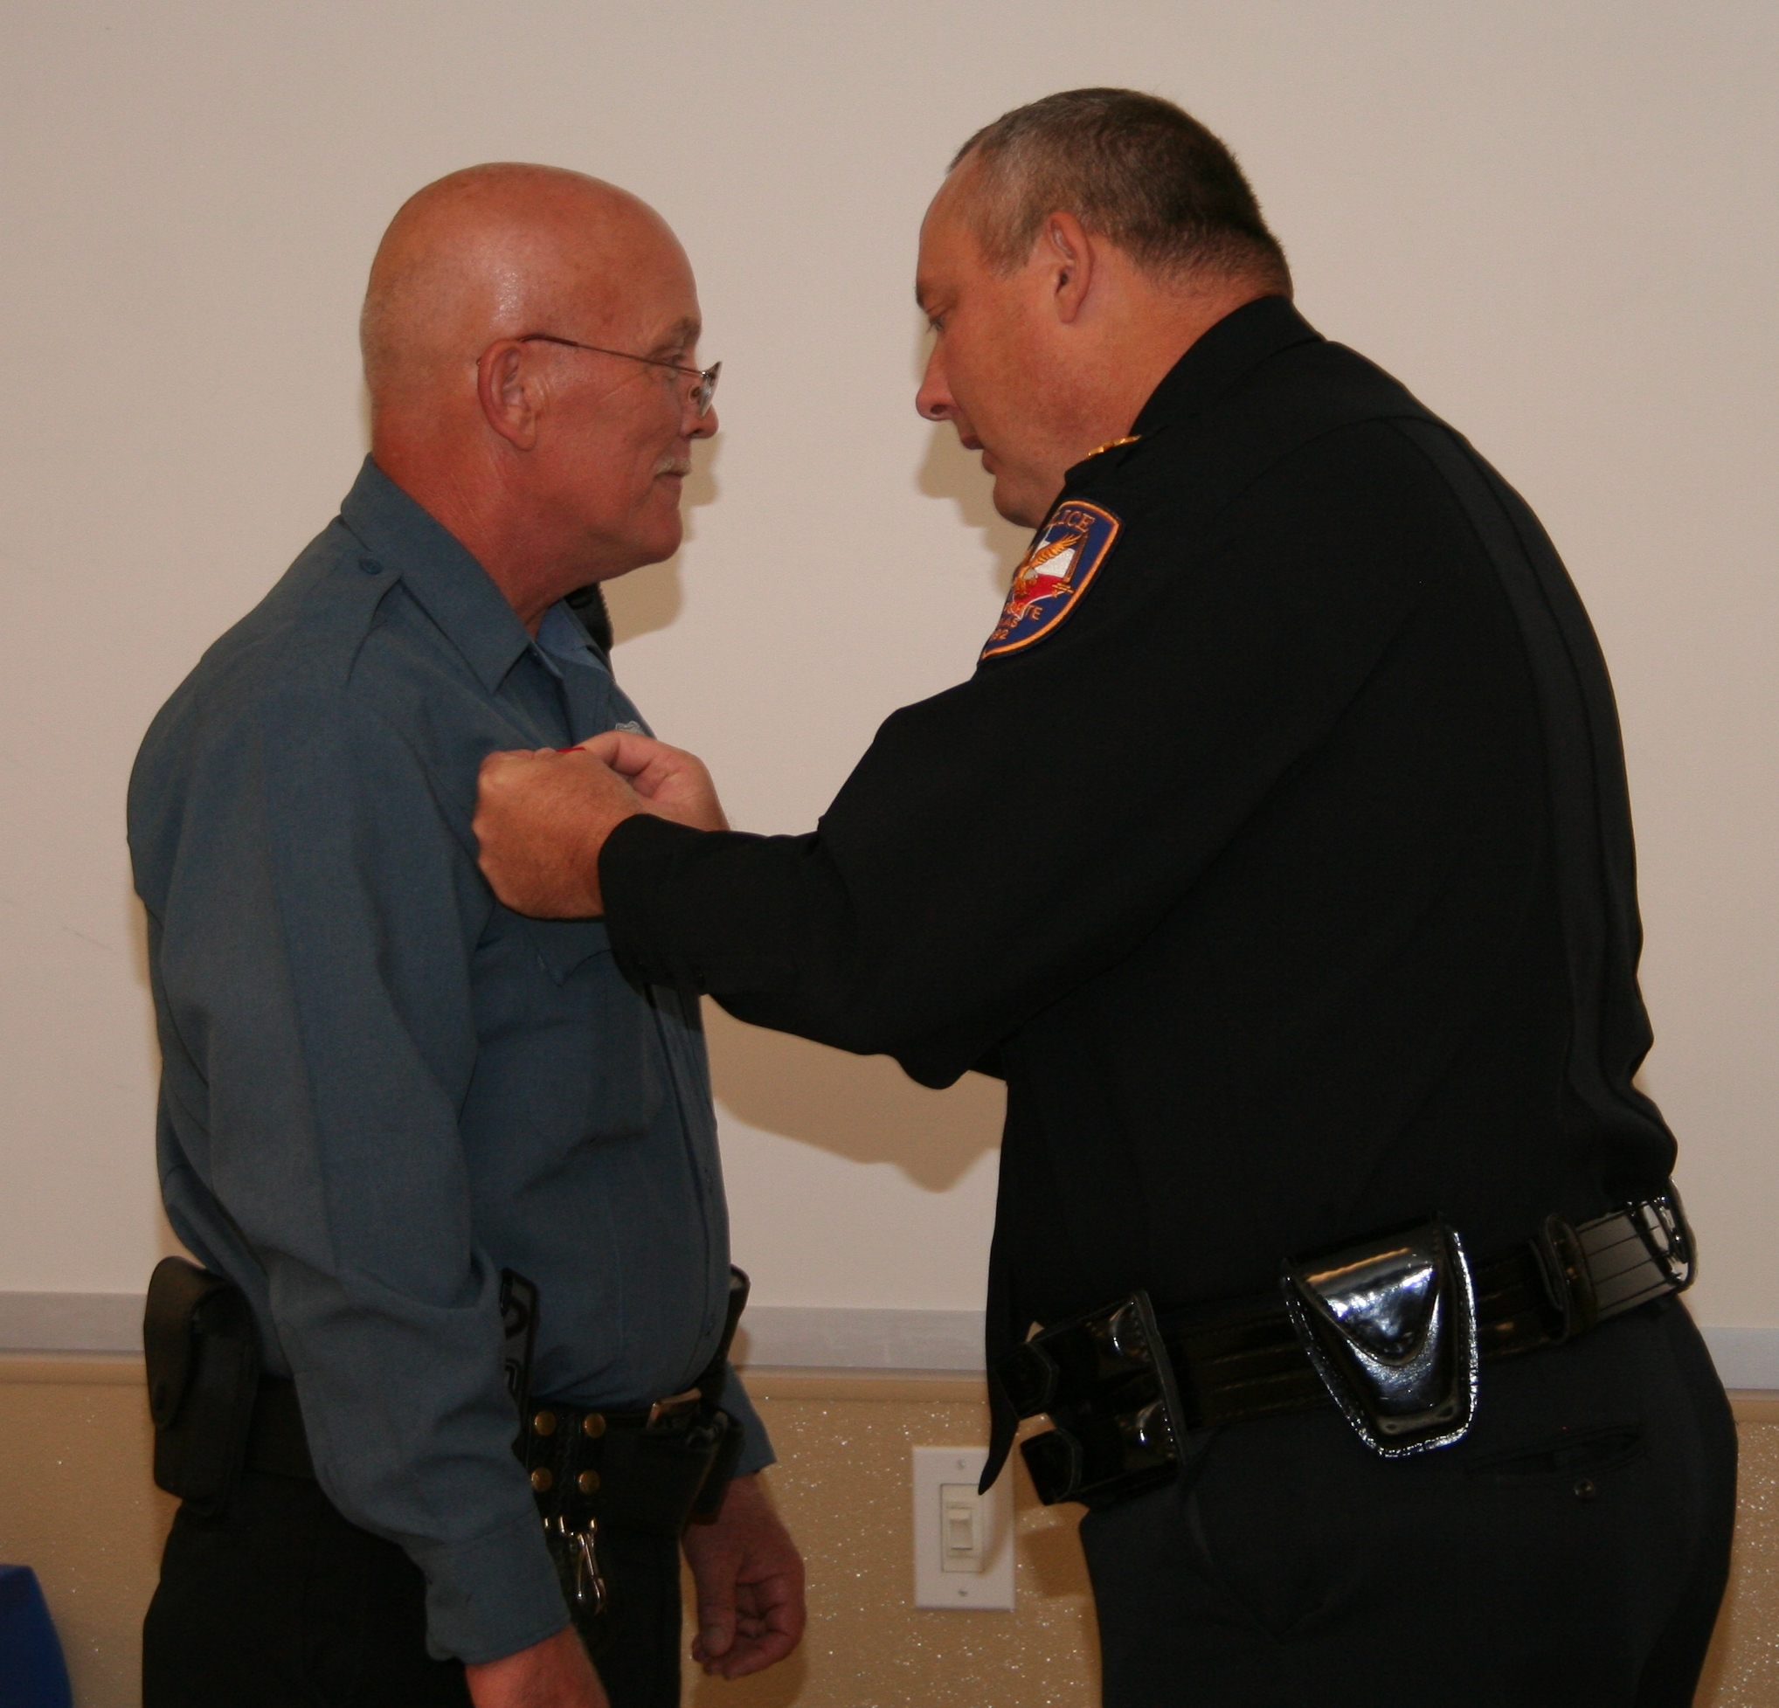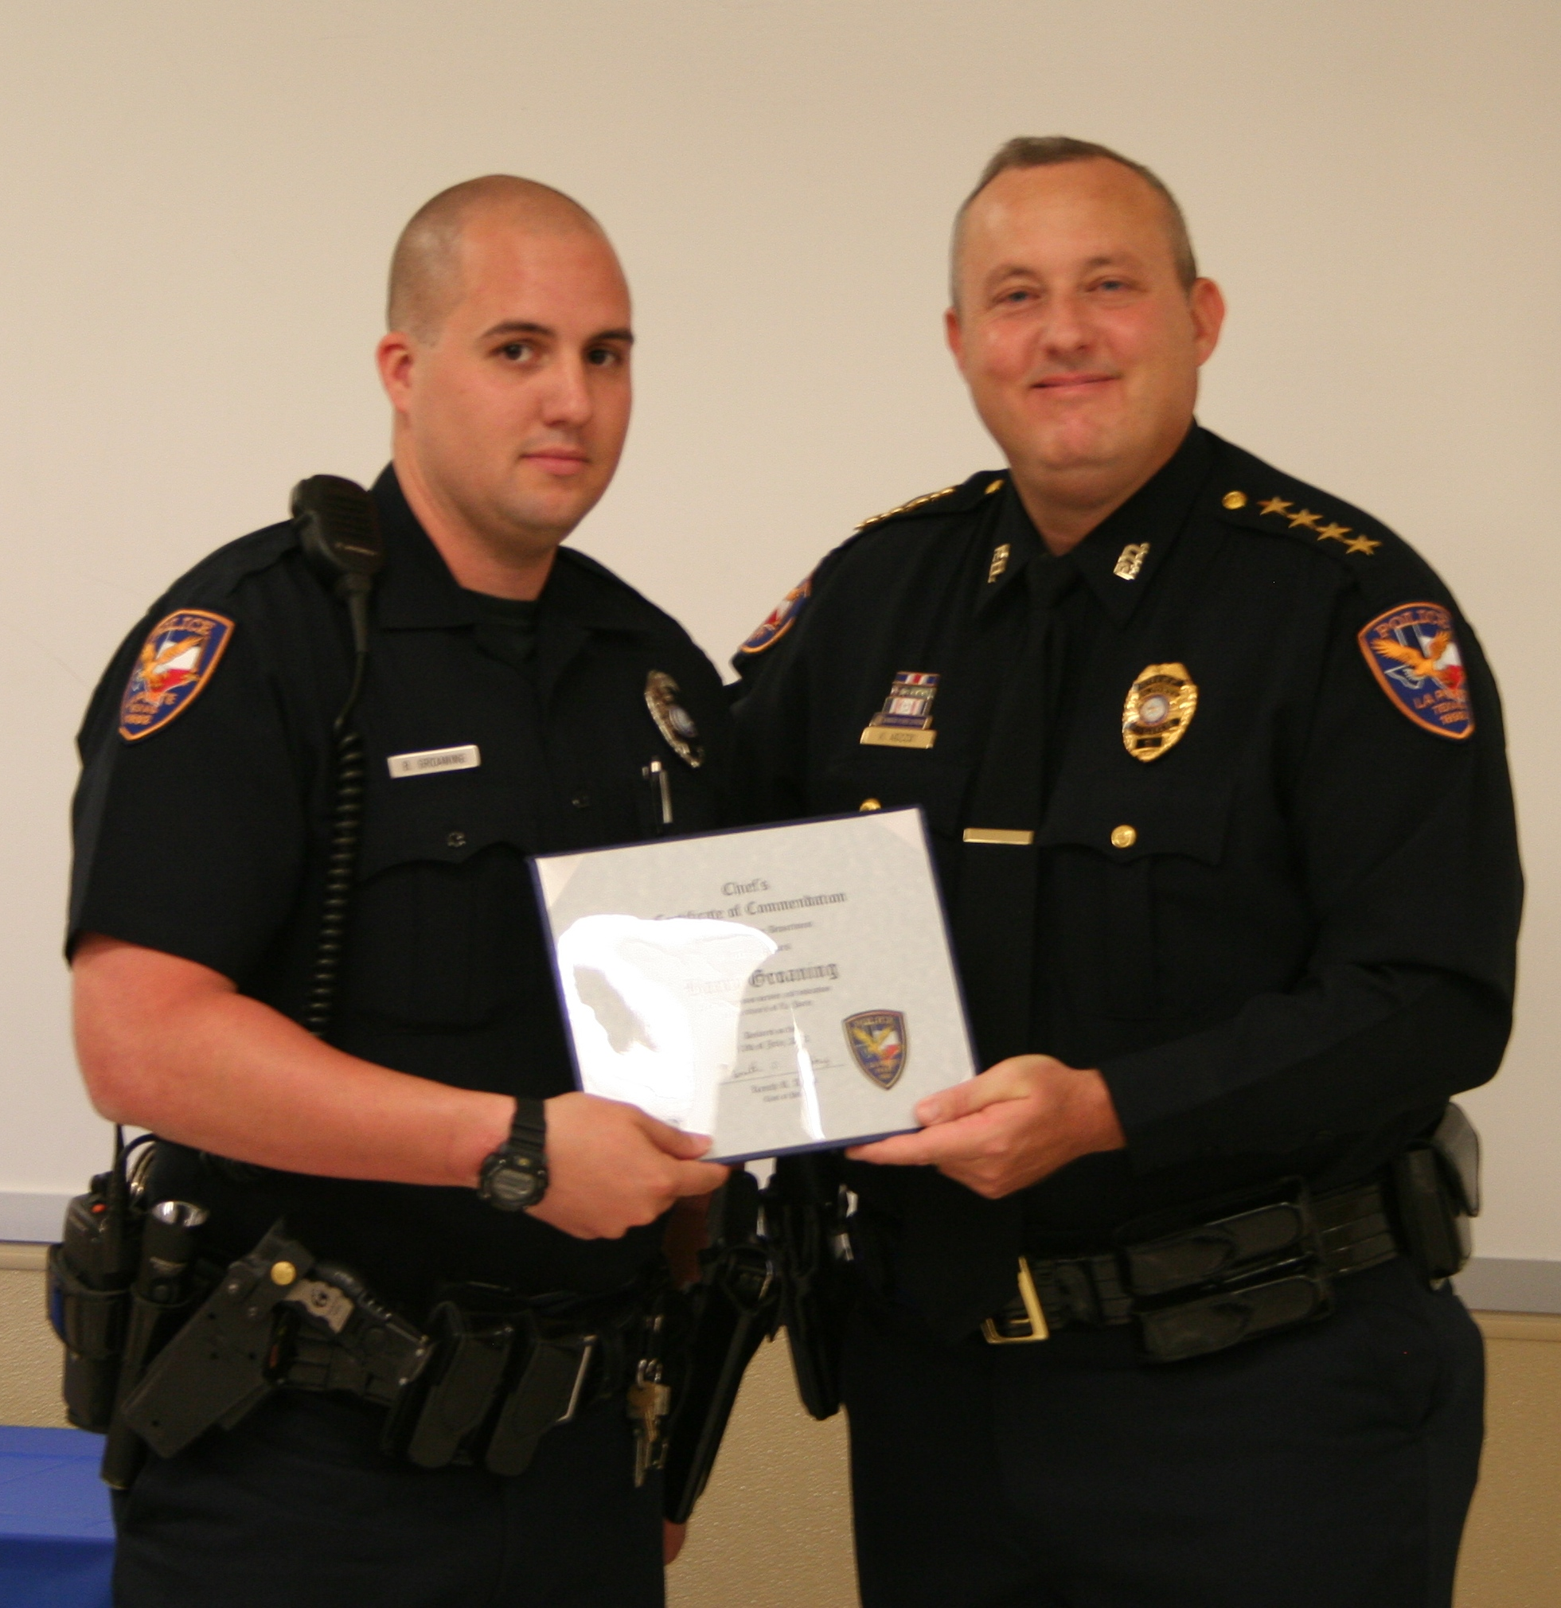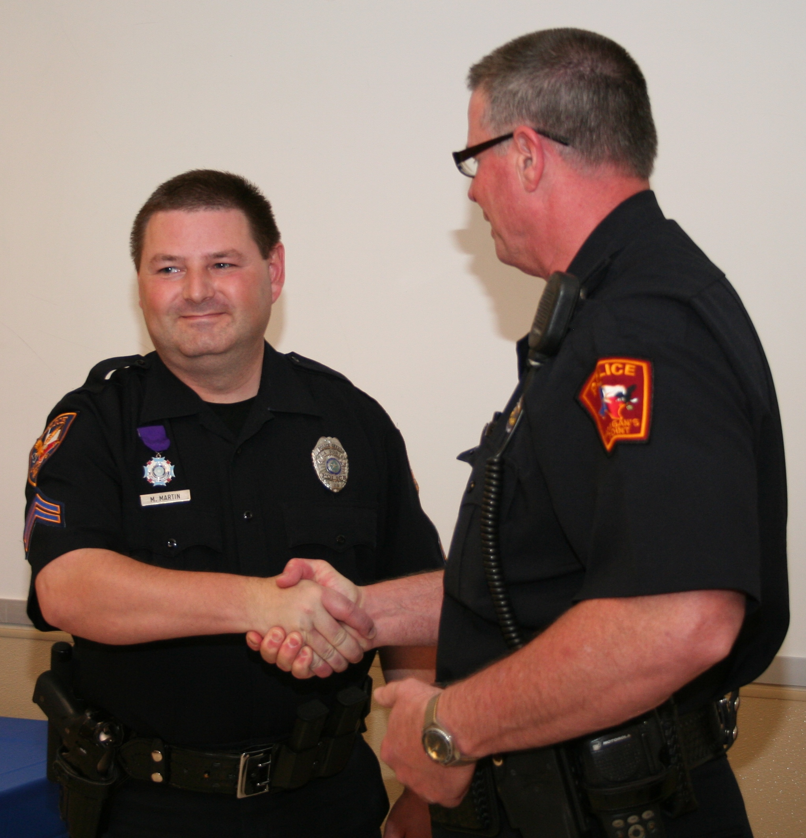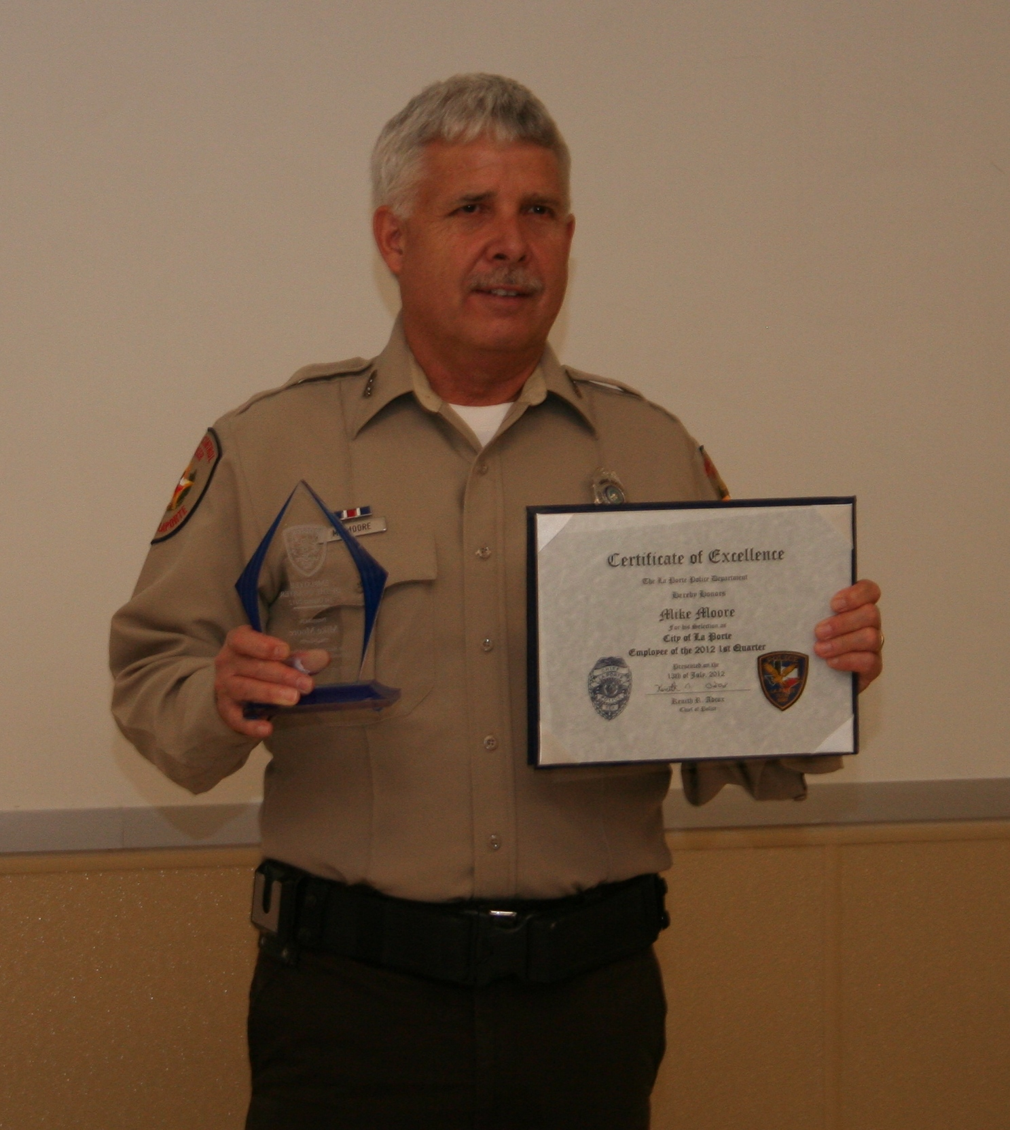

(L-R) PSA J. Harrington, Ofc. B. Groaning, Ofc. M. Martin, ACO M. Moore,
Res. Ofc. T. Stiver

While self-sacrifice is a part every public servants duty, some go the extra mile as they perform this calling. To recognize such acts, on Friday July 13th, La Porte Police Department took time out to recognize some of those who have clearly gone above and beyond the call of duty.
Life Saving recognitions were presented to Jailer John Harrington and LPPD Officer Barry Groaning for acts which clearly exhibited an essential rescue. Specifically addressed were incidents occurring earlier this year where Harrington’s quick reaction to a suicidal prisoner in the jail facility thwarted an inmate’s attempt to hang himself, while Groaning was commended for superior observation and quick action involving an elderly resident who had fallen and was incapacitated within his own home.
Officer Mike Martin was awarded the agency’s Purple Heart for a serious injury he sustained in the line of duty, when a 2002 foot pursuit led to a physical fight where Martin received significant back and knee injuries which later required extensive surgeries and rehabilitation. Admirably, as the recognized event became damaging, Martin did not quit until the suspect was arrested. Moreover, Officer Martin continues to serve the Patrol Division, still a decade later.
Animal Control Officer Mike Moore received the Department’s Spring 2012 Employee of the Quarter award. Moore was unanimously selected by the agency’s awards committee for his ongoing efforts in animal rescue and adoption accomplishments; resulting in a 44% increase in animal placements during the past two years.
Finally, LPPD Chief Ken Adcox officially swore-in Travis Stiver as the latest addition to the agency’s Reserve Officer program. Stiver, who is already employed as one of the department jailers, recently put himself through a State-certified police academy and has since been volunteering for police patrol duty a few days each week.
These examples, and many unlisted, occur every day among the LPPD ranks. Both sworn Officers and civilian staff members give of their time well-beyond the daily requirements, and the Department is proud to be able to recognize them. For more information on the La Porte Police Department, visit the agency website at http://www.laportetx.gov/police/default.asp

