Media Relations Information for 10/10/2011
Public Relations Officer – Sgt. John Krueger
Office: 281-842-3161

LPPD’s 2011 National Night Out a major success

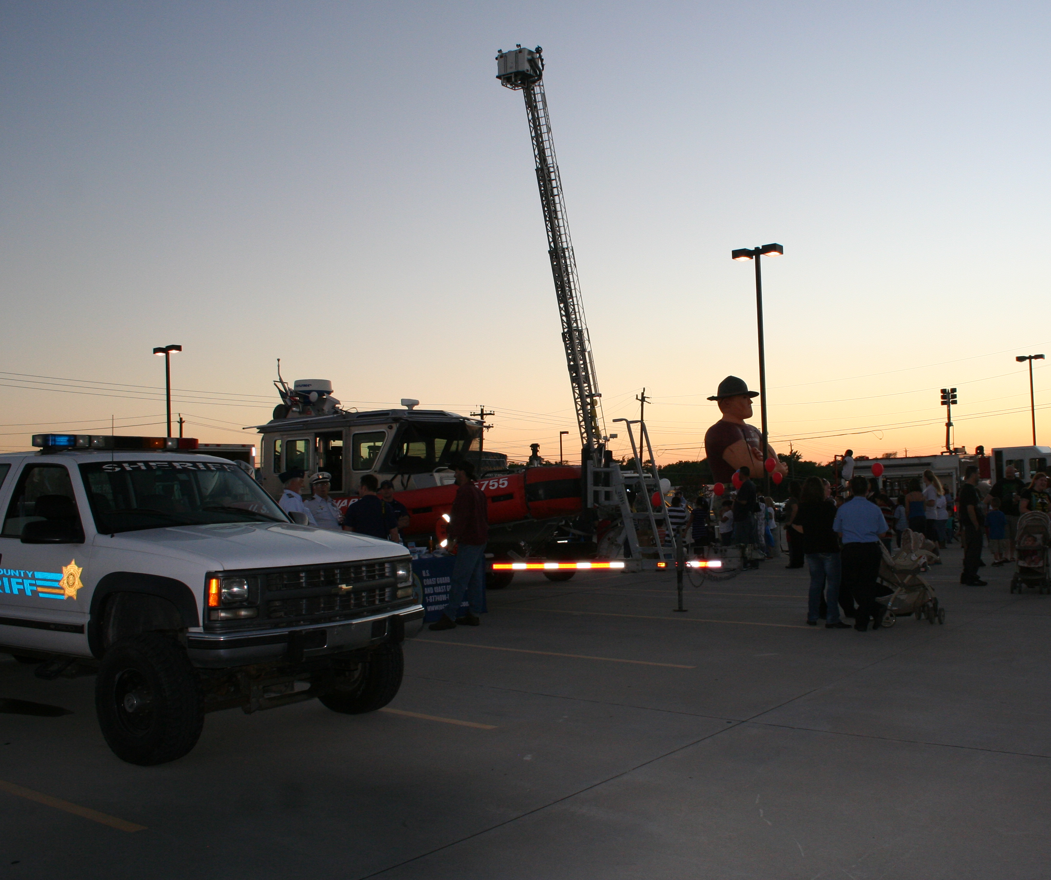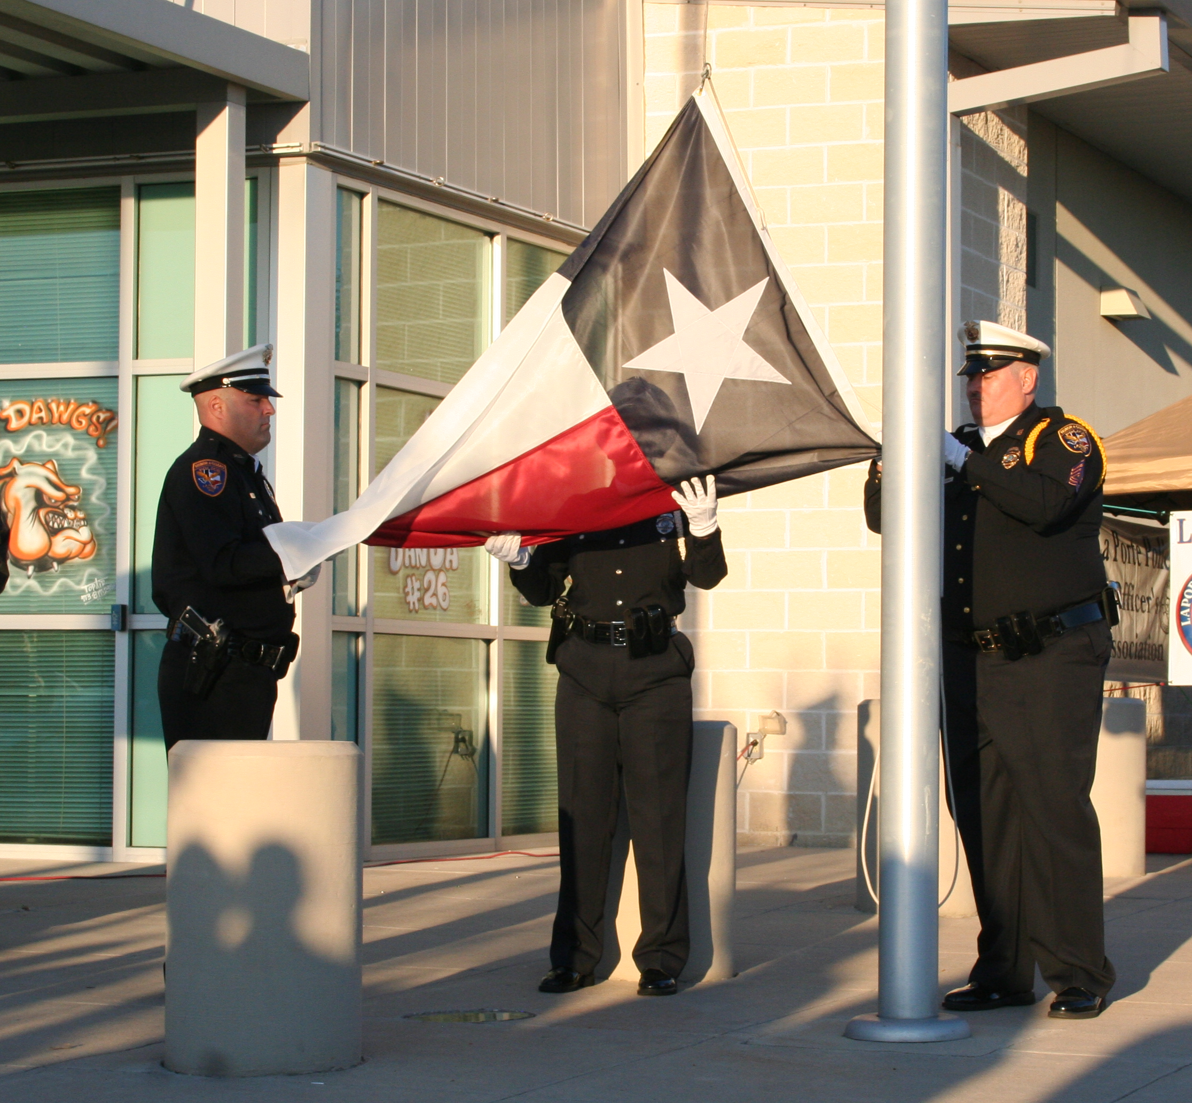

On the evening of October 4th, 2011, the La Porte Police Department, hosted its 3rd Annual National Night Out event. The event turned out to be the largest yet for the City, with nearly 600 citizens enjoying the night’s festivities, which included various public safety displays and demonstrations from several area law enforcement and emergency services agencies, the U.S. military, regional safety organizations, and local citizens groups.

During the event, the Police Department also made a special presentation, renaming the La Porte Police Department’s new facility, located at 3001 N. 23rd Street, the Herbert F. Freeman Jr. Police Administration Building, after the City’s first ever police chief. Freeman served as the City’s Police Chief from 1961 to 1985 and had remained active in the La Porte Community until his passing last March. A special Proclamation and Texas Flag were presented to the Freeman family in memory and honor of Chief Freeman.

For more information on La Porte Police Department’s community outreach activities, please contact the Support Services Division at 281-842-3162 or 281-842-3183.

