Media Relations Information for 06/07/2012
Public Relations Officer – Sgt. John Krueger
Office: 281-842-3161

LPPD & alert residents stop multiple vehicle crimes, solve others. Yet, continued vigilance stressed

Burglary of Motor Vehicle Felony Theft (from Motor Vehicle)
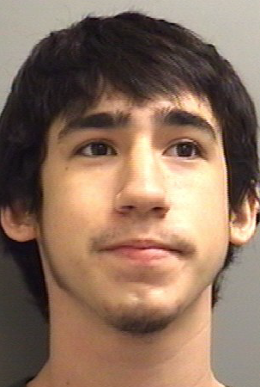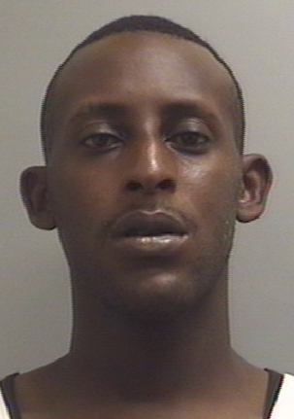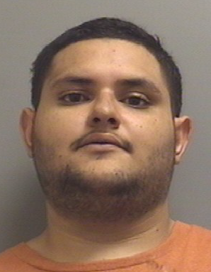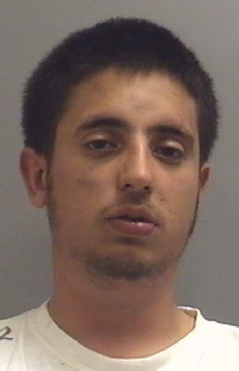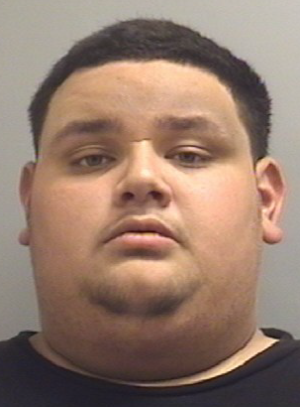
Taylor Ashton Ellard Ivory Junior Whitfield Raul Alfonso Martinez Julio Cesar Chapa Julio Cesar Martinez
08/27/1991 04/24/1980 12/27/1989 01/10/1993 01/10/1994

While residents of La Porte continue to enjoy a relatively low crime rate overall, property crimes remain a menace within nearly all regional communities. Over the first week of June, a series of burglaries of and thefts from motor vehicles plagued the La Porte neighborhoods of Glen Meadows, Brookglen, and Lomax. With the aid of vigilant La Porte residents, however, the La Porte Police Department was able to bring resolution to each of these crimes through the identification and arrest of 5 different suspects.

The first series of crimes occurred in La Porte’s Glen Meadows subdivision and involved the burglary of 8 different vehicles. The break occurred when LPPD received a tip from a local resident about various stolen items being advertised for sale. La Porte Police investigators initiated an undercover operation in an effort to root out the suspect, by initiating a series of correspondences with the would-be seller. Undercover detectives were quickly able to track down the vendor within a matter of days and, shortly after, obtained an arrest warrant for the suspect, which resulted in 20 year-old Taylor Ashton Ellard of La Porte being arrested on Wednesday June 6th under charges of Burglary of a Motor Vehicle.

Just one day after the original filing of Ellard’s arrest warrant, residents from La Porte’s Brookglen subdivision alerted police of an suspicious person seen walking along residential streets with a flashlight in hand shortly after 3:00 a.m. Several LPPD Patrolmen immediately responded to the area and were able to quickly locate the man in the 8500 block of Fairbrook lane. After observing wiring and cords protruding from his pockets, police identified the man as 32 year-old Ivory Whitfield of Pasadena. Further investigation reveled that Whitfield was wanted by Harris County Sheriff’s Office for an unrelated arrest warrant. As Whitfield was being taken into custody for the outstanding warrants, he was discovered in the possession of several stolen items. Whitfield was soon-after linked to as many as 4 Burglary of Motor Vehicle offenses, which had occurred earlier that same evening.

The following night, La Porte Patrolmen responded to a call in one of La Porte’s Lomax-area subdivisions, where a resident had observed their neighbor’s vehicle tires being stolen from a parked SUV just after 1 a.m. As the vehicle was parked in the 9700 block of Blazing Star drive, three Hispanic males began removing the vehicle’s wheels/rims right from the vehicle axles. However, as they were 3/4–way through their crime, responding officers caught them in the act and arrested 22 year-old Raul Martinez of Pasadena and 19 year-old Julio Cesar Chapa and 18 year-old Julio Cesar Martinez, both of Houston. The suspects have since been linked to as many as three additional felony theft cases involving vehicles parked among roadways and residences within La Porte’s Fairmont Park West subdivision over the past several nights.

Although the offenders in the above mentioned crimes have been apprehended, the La Porte Police Department is reminding community members that no area is immune from crime. In order to aid the La Porte Police in the prevention of such crimes, the Police are urging residents to follow these three simple steps, which have been shown nationwide to be effective means of motor vehicle burglary deterrence:

- Park your vehicle in a secure location.
Studies have shown that vehicles parked in the street have a 120% higher chance of becoming burglarized than those in garages. And, while percentages for parking in a driveway are not as high as a garage, vehicles parked in a driveway also have a reduced chance of break-in when compared to those parked curbside. LPPD advises that the best way to combat motor vehicle burglaries is to utilize the proven deterrents of all residential crime: keeping hedges trimmed, removing low hanging tree branches, installing outdoor lighting, and utilizing locking devices.

- Lock any unoccupied vehicles.
City-wide, an overwhelming percentage of all reported burglaries repeatedly involve unlocked vehicles. In fact, since 2012 began, 76% of the Burglary of Motor Vehicle events throughout the City of La Porte have involved unlocked vehicles. Not only do unlocked vehicle make easier targets for criminals, but once inside a vehicle, burglars tend to choose small, easy to carry, electronic items which typically do not have serial numbers recorded and can also be sold for a quick profit. GPS units are particularly sought after, but stereo equipment, laptops, cell phones, and loose change are also desirable. Simply recording model and/or serial numbers, and removing any valuables from plain sight, can deter criminals and enable the police to track items.

- Immediately report suspicious people in and around your neighborhood.
Reporting suspicious people to the police helps track the movements and patterns of criminals which may also link them to other crimes. In all three of the listed cases, alert citizens were the catalyst in catching the offenders. As evidenced by the above mentioned cases, the police department’s mission of prevention and solving crimes can be aided substantially by involved citizens who are willing to serve as an extra set of eyes and ears within their own neighborhoods.

To report motor vehicle crimes, or suspicious activity of any kind, please contact the La Porte Police Department at 281-842-2141. In addition, if you wish to speak with a crime prevention specialist, call 281-842-3183 or 281-842-3162.

