Media Relations Information for 07/18/2012
Public Relations Officer – Sgt. John Krueger
Office: 281-842-3161

2 of 3 LPHS swimming pool bandits apprehended by police
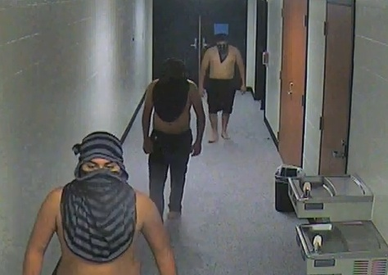
Contributed photo/Crime Stoppers Suspect still sought by police

As a result of several Crime Stoppers tips, detectives from the La Porte Police were able to locate and file charges on two of the three suspects in a recent high school vandalism case which occurred the morning of July 4th.

The original incident, occurring shortly after 1:00 a.m. on July 4th, involved three masked males, absent shirts and shoes, breaking through a series of fiberglass panels surrounding La Porte High School’s Swimming Pool facility. Shortly after their break-in, the group began throwing various chairs, benches, tables, and other nearby accessories into the school pool. LPHS surveillance footage revealed the trio as scouring the entire pool area, surrounding corridors, and equipment rooms. Fortunately, with their images being quite clear on the surveillance cameras, a Crime Stoppers posting of the event was quickly spotted by concerned residents. As a result of Crime Stopper tips, and a detailed series of exploratory procedures by LPPD investigators, two of the males were promptly identified.

Both males interviewed by La Porte Police were juvenile brothers who reside in La Porte and Baytown. The suspects were able to name the third suspect, also a juvenile, but were unable to provide more than a name. The third suspect, depicted wearing a black and gray striped head/face covering in the accompanying photos, currently remains at large. The case remains open at this time and the third suspect is believed to live in the Pasadena or South Houston area.

LPPD investigators have presented the case information thus far, along with the identities of the two juveniles, to the Harris County District Attorney’s Office, and charges of Criminal Mischief were accepted against each member. Since the damage inflicted by the suspects was estimated to have exceeded $1000, under the Texas Penal Code, each will face Class A Misdemeanor charges, a punishment category carrying the possibility of a $4000 fine and/or as much as a year in jail.

While the concerned citizen providing the essential tip remains anonymous, as part of the standard Crime Stoppers process, La Porte Police praise them for their dedication, and readily advocate that such examples of citizen participation encompass the vital spirit necessary for a thriving community.

Anyone with additional information regarding this incident, or any other area crime, is encouraged to contact Houston-area Crime Stoppers at 713-222-TIPS (8477).

