***Media Relations Information for 02/16/2012***

*Public Relations Officer – Sgt. John Krueger*

*Office: 281-842-3161*

**LPPD’s K-9 division still one of the top in the region**

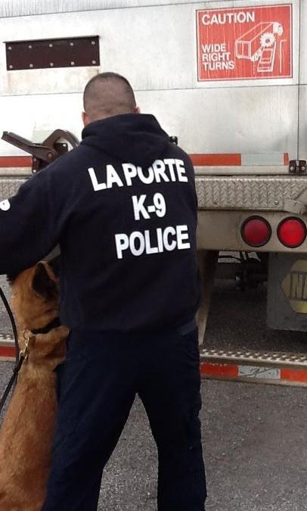

La Porte Officer Jesse Arenivas searches an 18-wheeler

with K-9 partner “Lodka”

Since the 2009 start of La Porte Police Department’s K-9 program, the pair of K-9 teams have remained quite active. Narcotic-related arrests and other patrol assistance endeavors have led the division to become an invaluable resource for the agency. Of most recent note, one of the K-9 teams, composed of La Porte Officer Jesse Arenivas and canine partner “Lodka”, placed in the top ten for the third year in row as they participated in the **National** **Narcotic** **Detector** **Dog** **Association’s (NNDDA) 2012 regional skills competition.**

For this year’s competition, Officer Arenivas and Lodka appeared in Angleton, Texas, where the pair found themselves among over 100 law enforcement agencies representing various organizations from both Texas and Louisiana. As in previous years, a wide range of training and skills competitions were evaluated for each K-9 team and, when the event was concluded, Arenivas and Lodka proved themselves to be a force to be reckoned with for yet another year.

**Both the narcotic detection competition and a separate team certification process are hosted bi-annually by the National** **Narcotic** **Detector** **Dog** **Association (NNDDA). The NNDDA is a professional, nonprofit organization dedicated to the utilization and proficiency of narcotic scent detector dogs. Their purpose is to provide training specifically related to the laws of search and seizure, by utilizing scent detector dogs and methods of certification for court purposes. Training consists of two days dedicated to hands-on classroom instruction, while the final three days of the week are dedicated to skills testing and the individual K-9 team competitions.**

**T**he NNDDA hosts a total of three competitions, including fugitive apprehension, explosives detection, and the narcotics detection contest. The narcotic contest, in which La Porte’s team competed, involved a timed event where the K-9 team was required to locate various types of narcotics within an expansive warehouse setting. Teams also carried the risk of being penalized for improper techniques or if dogs alerted on areas where no contraband was hidden. In spite of these challenges, La Porte handler Arenivas and partner “Lodka” proved up to the task.

For more information regarding the La Porte Police Department’s K-9 program, please contact the Department’s Patrol Operations Division at 281-842-3184 or log onto the department’s website, located at www.laportetx.gov/police/.