Media Relations Information for 07/11/2012
Public Relations Officer – Sgt. John Krueger
Office: 281-842-3161
La Porte Police Bomb Squad Acquires HMMMV through Military Surplus Program

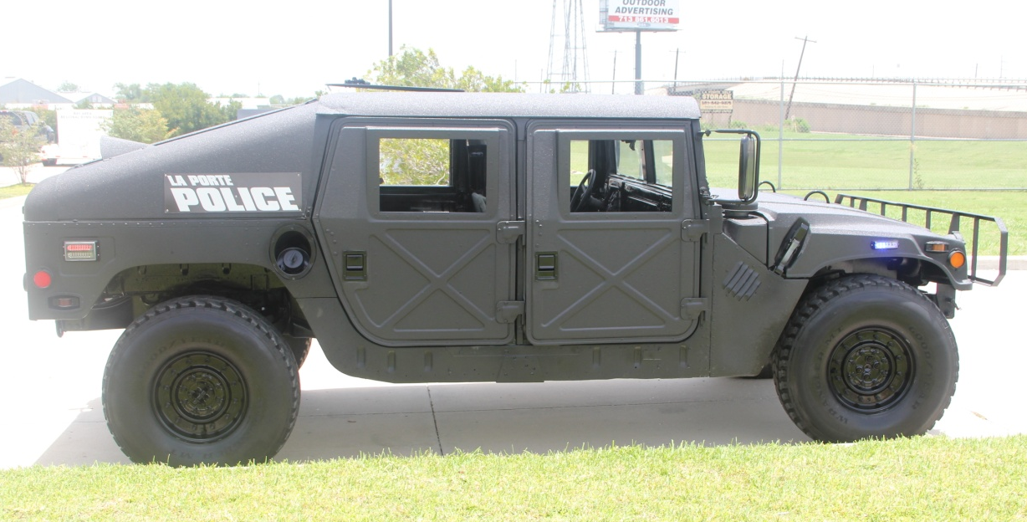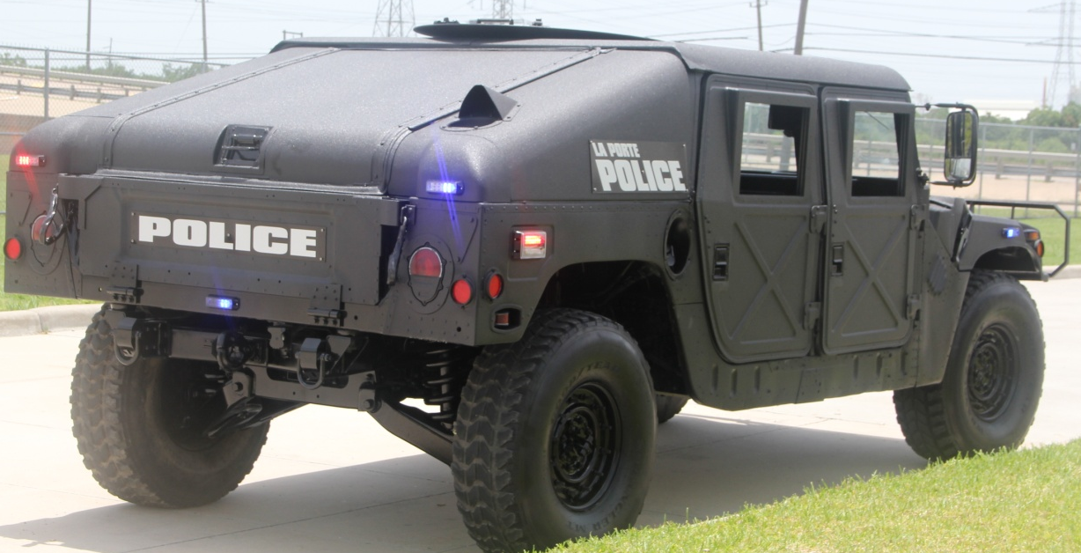

As a result of the U.S. military surplus program, La Porte PD recently benefited from the acquisition of a heavy-duty HMMWV utility vehicle. The vehicle has just completed the final stages of restoration and is now part of the LPPD fleet.

The HMMWV, which has more recently morphed into the familiar commercial “Hummer”, is the original style light off-road vehicle used by the military over the past few decades. Under the military surplus program, decommissioned military equipment, such as the HMMVV, are made available to local law enforcement agencies that are able to demonstrate an appropriate need.

The surplus vehicle arrived in La Porte with several necessary upgrades and alterations, but was soon ready for duty with the help of several local area businesses. The Sulzer Corporation provided various forms of metal fabrication, local A & I Industrial Services offered sandblasting, and All American Sales provided emergency LED lighting, all at no cost. Toff Liners and Charlie Hinds Paint & Body supplied material for painting the vehicle at a much reduced cost and the vehicle was painted with the assistance of veteran painter Jesse Ruiz who volunteered his time to complete the project.

By adding such a vehicle to the La Porte Police fleet the City of La Porte stands to benefit immensely, as the new addition will serve in the capacity of towing vehicle for the Department’s existing Bomb Squad explosive containment apparatus as well as an additional means of equipment transport for the department’s other specialty teams such as S.W.A.T. As an added function, the vehicle is also equipped to move through high-water, which will prove extremely useful during flood related events.

For more information relating to the La Porte Police Department’s Bomb Squad or other specialty teams, please contact Assistant Chief Steve Deardorff at 281-842-3139.

