Media Relations Information for 08/20/2012
Public Relations Officer – Sgt. John Krueger
Office: 281-842-3161

Credible tips help La Porte Detectives make quick work of Graffiti bandits.

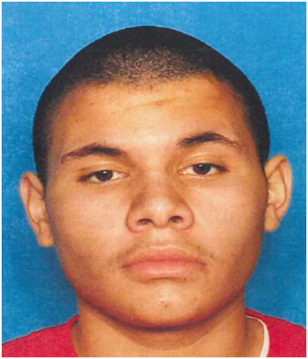
Joshua Huerta
05/20/93

Last week La Porte Police Department filed charges against 19 year-old Joshua G. Huerta of La Porte for multiple acts of Graffiti, as well as a La Porte area juvenile for separate Graffiti offenses.

Similar cases against the two suspects began in late June when a series of Graffiti postings began appearing along La Porte’s South Broadway, as well as adjacent streets. Criminal investigators from the Department’s Investigations and Street Crimes units worked on diligently on each of the cases and were subsequently able to identify those responsible.

Huerta, who recently moved to La Porte from San Antonio, is now charged with a State Jail felony for his acts of Graffiti. The second suspect, a juvenile who lives in La Porte, was also charged with several graffiti related cases. The juvenile’s name is not being released due to his age.

If you have any information on local acts of Graffiti or any other crimes, you may contact the La Porte Police Department at 281-471-2141 and file a report.

