Media Relations Information for 04/--/2012
Public Relations Officer – Sgt. John Krueger
Office: 281-842-3161

LPPD volunteer groups team-up for second annual garage sale and car wash

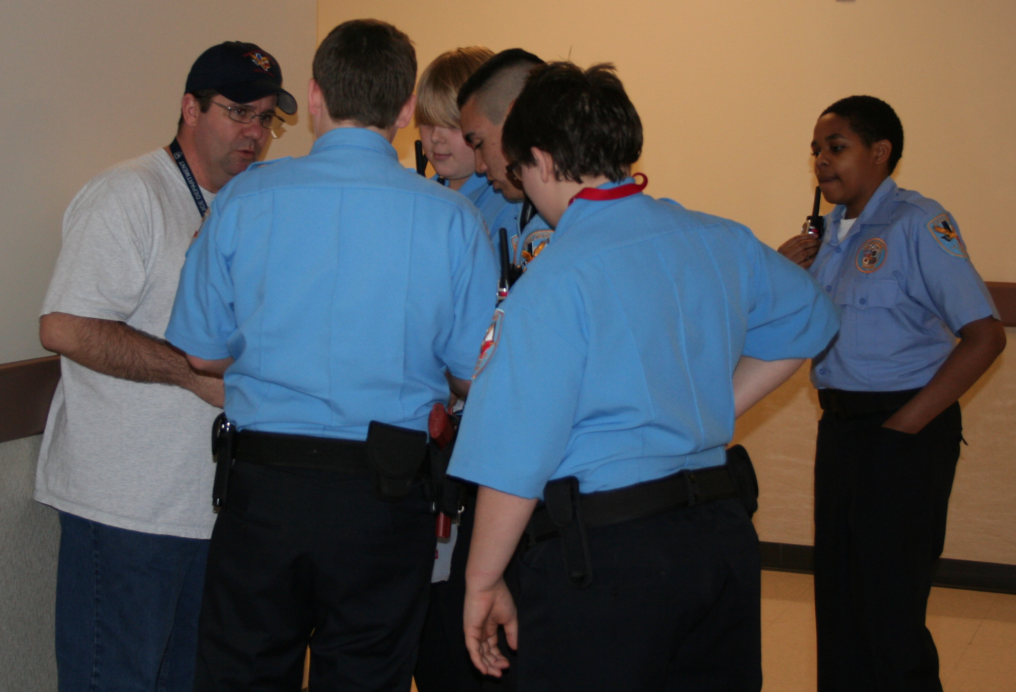
Members of La Porte’s Citizen Police Academy Alumni Association are known to unite with youth Explorers during many community projects.

Community service outreach efforts have become quite common among the members of La Porte’s Citizen Police Academy Alumni Association (LPCPAAA), as well as the Police agency’s youth Explorers in recent months. In step with such activities, on April 21st, 2012 the LPCPAAA will be hosting their 2nd Annual Blue Santa Garage Sale from 8am to 2pm at the La Porte Police Department (3001 North 23rd Street in La Porte). However, as an added bonus, the youth Explorer group will be outside of the police station washing attendee’s cars during the event.

Funds raised from the Blue Santa Program go toward purchasing new toys for less fortunate children during the Christmas season. Last year, the Alumni Association linked with the La Porte Neighborhood Center, Inc. where the donated toys were wrapped and distributed by both LPCPAAA members as well as other community volunteers. In the end, proceeds from the 2011 garage sale totaled $1300.00.

For this year’s event, LPCPAAA members will give a repeat performance and begin collecting garage sale-type items at the police department on Friday April 20th. All items will be priced and then sold the following day in order to raise funds for the Blue Santa Program. However, for this year’s event, there will be an extra service installment. In conjunction with the Blue Santa Garage Sale, the La Porte Police Department Explorer Post will be holding a car wash to raise money for upcoming state-based Explorer competitions. Funds collected have the potential to cover both entry fees for the youth group, as well as added travel costs and any unforeseen equipment issues which may arise.

The La Porte Police Department would like to invite all area residents to browse among the garage sale items on Saturday the 21st while have their car washed in support of both credible endeavors. For more information on the LPCPAAA’s activities, log onto http://www.lpcpaaa.org/blue-santa-2012/. Or, if you have any questions regarding the La Porte Police youth Explorer program, please contact Officer Roger Gonzalez at 281-842-3183.

