Media Relations Information for 07/12/2012
Public Relations Officer – Sgt. John Krueger
Office: 281-842-3161

La Porte DARE car wins State competition and heads for national conference

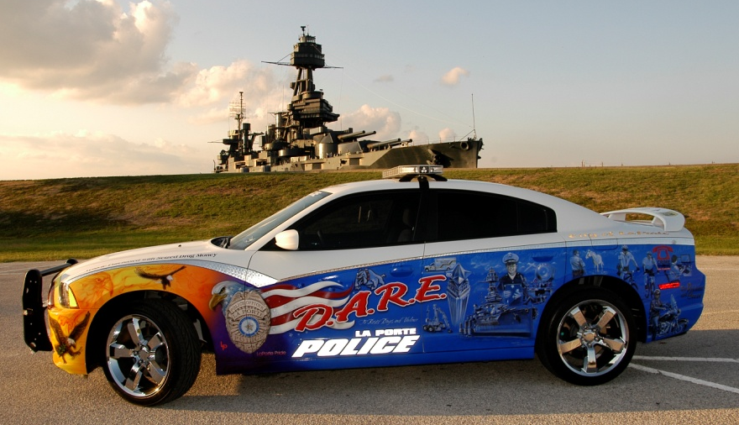
LPPD’s DARE vehicle

La Porte Police Department DARE Officer Yvonne Stanley recently returned from the Texas State DARE Competition, held in Eagle Pass, with a first place trophy recognizing the LPPD’s new DARE Car as the best in the State. During the event, the Texas DARE Officers Association (TDOA) also selected Stanley and her DARE Car to represent the State at this year’s National DARE Conference, to be held in Atlanta, Georgia. TDOA will pay for conference registration fees, hotel during the conference, and per diem for Officer Stanley, as well as all fuel costs to and from the conference. Officer Stanley will attend the Conference from July 24th - 26th.

La Porte Police Department and the Independent School District work hand-in-hand to provide the core curriculum of the D.A.R.E. program annually at the Baker 6th grade campus, where all 6th graders in the City of La Porte attend school. The School District also provides Officer Stanley with her own classroom. In addition to teaching the 6th grade DARE curriculum, Officer Stanley also makes periodic visits to seven other LPISD K thru 5th grade elementary schools in order to share her anti-drug messages.

Attending the State and National DARE Conference will aid in equipping Officer Stanley with the latest tools and knowledge needed to continue her work as a DARE Officer. The DARE Car was purchased using seized drug money and is designed to capture and hold the attention of DARE’s school-aged target audience. LPPD officials were quick to credit the DARE car’s custom paint job, completed by La Porte’s own Coupland Signs, as the most unique element of the vehicle. The graphics represent over 50 hours of donated time from the company’s owner and resident artist, Chuck Coupland. Other businesses that donated products or services to the new D.A.R.E. vehicle include, Charlie Hinds Paint & Body, Discount Tire Co., Stanley Parts & Equipment, Texas Honor Ride, R&R Kustom Kar Stereo, La Porte Police Officers Association, Best Buy Stores, Viper, and Blue Knights Texas VII.

For more information on the La Porte Police DARE program, contact Officer Stanley at 281-830-5208, or log onto the department website at www.laportetx.gov/police/default.asp to learn more about the DARE program and some of the agency’s current and upcoming Summer Safety Camps.

