August 2012
Aggravated Robbery Suspect

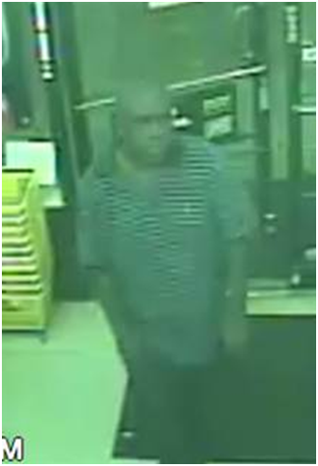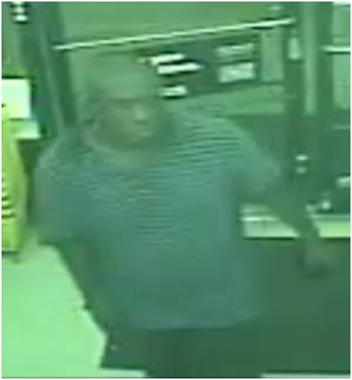

The above images, depicting a suspect in a recent aggravated robbery case, were captured by a business surveillance camera at approximately 8:40 p.m. on August 9th, 2012.

The suspect in this image appears to be wearing a gray polo shirt with horizontal stripes. The suspect is alleged to have entered La Porte’s east-side Dollar General store (located in the 1200 block of South Broadway), soon-after producing a silver-colored handgun, and demanding money from the business’ cash registers. Clerks provided the suspect with the register’s cash contents and noticed the suspect left the store in a northbound direction, toward Fairmont Parkway. It is unknown at this time if the suspect continued on foot or entered a near-by vehicle.

The suspect was described by store clerks as a Black male, estimated to be near 5’6”, with a stocky build and closely shaven dark-colored hair.

If you recognize the suspect or have any information concerning the crime, please contact La Porte Police Department’s Criminal Investigation Division at 281-842-3173.

