Media Relations Information for 01/27/2012
Public Relations Officer – Sgt. John Krueger
Office: 281-842-3161

La Porte Investigators look for Burglar Trio

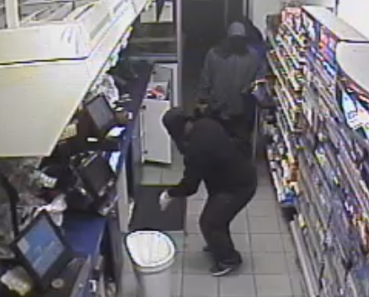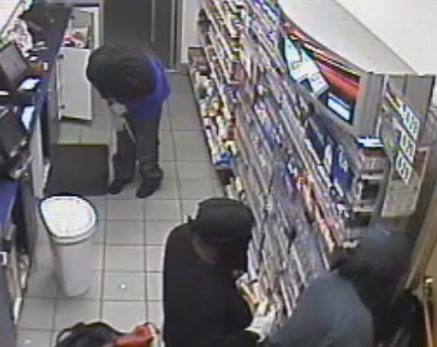
Images of three burglar suspects inside of convenience store in the 1400 blk. of Sens Road

Investigators at the La Porte Police Department are utilizing a series of video images, in conjunction with additional crime-scene evidence, in order to determine the identities of three burglars responsible for the forced entry and subsequent theft at a La Porte convenience store.

On Wednesday 01/25/2012 at approximately 3:42 a.m. three suspects made a forced entry into a Valero convenience store in the 1400 block of Sens Road. Entry was obtained as the suspects each worked with crowbars to pry front door burglar bars and door frame panels until access to the store was made. Once inside of the business, the suspects stole multiple cartons of cigarettes with a retail value of approximately $2400, and also made a failed attempt to enter a floor safe. While the video footage collected is quite clear, none of the images provide direct information for detectives to work with, regarding the identities of the three suspects.

Depicted at the head of this article are images of the suspects, which were captured by one of the convenience store’s internal surveillance cameras. While footage shows that the burglars were all wearing long sleeves, masks, and facial coverings, investigators observed slight breaks in the clothing which indicate all three of the suspects are dark-skinned males. Investigators are asking area citizens to take a good look at the photos and provide any information possible.

If you have any information on the burglary offense or recognize the suspects depicted, please contact the La Porte Police Department’s Criminal Investigations Division at 281-842-3173.

