Media Relations Information for 05/21/2012

La Porte Citizens Police Academy Alumni Association provides meals for officers during National Police Week

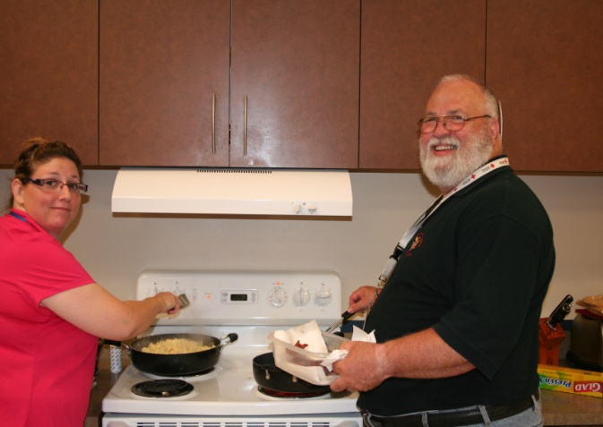
LPCPAAA Members Viki Ferguson and Richard La Porte and Morgans Point Officers each enjoyed
Manning preparing breakfast the LPCPAA’s efforts

While Police Officers may be part of the larger group of government services we all contribute toward, many serve in such a way that is truly above and beyond their call of duty. Countless officers provide advice, physical assistance, or perhaps a simple smile to multiple citizens on a daily basis, on top of the basic services they are hired to perform. In addition, there are numerous acts of volunteerism, social service, and community events in which officer engage on their days off, both inside and outside of their immediate communities. Therefore, in honor of National Police Week, and in support of their local officers, the La Porte Police Citizens Police Academy Alumni Association provided meals for officers on Wednesday, May 16th.
Officers from La Porte Police Department, Morgan’s Point Police Department, and Harris County Pct. 8 Constables Office enjoyed meals prepared by several LPCPAAA members for breakfast, lunch and dinner. Along with meals, homemade bake goods were available for dessert. The CPAAA also handed out door prizes to all those in attendance. Special thanks to all LPCPAAA members, Gringo’s Mexican Kitchen, Mesquite Grill and Taco Factory, Vesco, Kroger, Joe Hambrick Insurance, Discount Tires, Walmart, Food Fair, Tony’s BBQ, Sonic-La Porte, and Spotless Car Wash.

LPCPAAA’s efforts were just one of the many ways to continue nourishing their relationship with local law enforcement, by nourishing the public servants who ensure both their safety and security on a daily basis. In fact, the event was such a success, a few LPCPAAA members returned the next day and fed the officers lunch for a second day. Such a relationship between the two groups truly embodies the concept of community. For more information on the Alumni Association or its activities, log onto their website at www.lpcpaaa.org/

