Media Relations Information for 07/19/2012
Public Relations Officer – Sgt. John Krueger
Office: 281-842-3161

An added graduation for LPPD’s Citizens Police Academy program

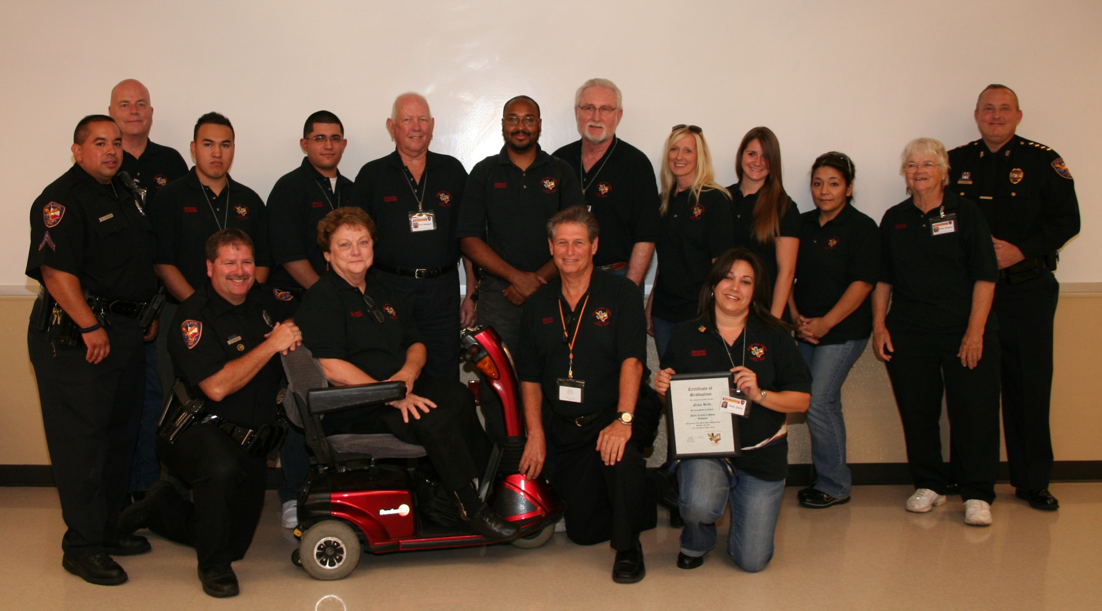
La Porte Police Department’s
Summer 2012 Citizen’s Police Academy Graduates

La Porte Police Department recently celebrated the graduation of another Citizens Police Academy (CPA) on July 17th, 2012. As the agency enjoyed the privilege of hosting a reception for course participants, the graduating members proudly shared their new-found success with family, friends, and their local police department.

Members of the class included Nikki Bello, Richard Browder, Virginia Chase, Charles Crittenden, William Davis, Alan Galvan, Aurelio Garcia, Ruth Greene, Margie Guerra, Ronald Simpson, Gary Tandy, Anja Zachrau, and Jana Zachrau. Officer Robyn Gallion gave another admirable performance in his role of Class Coordinator for the CPA class and was assisted at the graduation ceremonies by LPPD’s Officer Roger Gonzalez and Chief Ken Adcox. Each of the graduates was presented with an official diploma recognizing their dedication and accomplishments over the last 14 weeks and, as an added bonus, enjoyed the attendance of new City Manager Corby Alexander as he offered his congratulations to the class.

Officer Gallion highlighted the theme of the ceremonies as he expressed, “Instructing is a two-way street during our academies. Our CPA graduates may learn from the Police Department, but we also learn about many community needs through our close interaction with them”. Recent graduate Charles Crittenden also offered his praise of the program, exclaiming, “This class had more relevant information to me than any other continuing education class I have taken.”

The ultimate mission and primary focus of the CPA is to bring the Police Department and the community closer together by educating one another. The Department’s believes that the goal of establishing a safer community can best be achieved if the police and the community positively connect with one another. In short, the La Porte Citizen Police Academy is a community awareness program geared toward a partnership between the police department and the citizens they serve.

CPA participants attended classes at the La Porte Police Department every Tuesday night for 14 consecutive weeks, from 6:30 to 9:00 p.m. As with previous CPA classes the most recent participants were exposed to a large group of well-qualified instructors. Courses were all taught by city of La Porte Police Department employees, both certified police officers and civilian employees serving in specialized positions. To supplement the classroom instruction, hands-on training was offered to participants involving 15 areas of police operations, ranging from Special Weapons and Tactics to Community Policing.

Participation in the CPA is free and all materials are provided by the Police Department. Applicants must be at least eighteen years of age with a clear criminal history. This means that applicants can have no convictions for felony offenses, cannot be on probation for any reason, and must not have any outstanding warrants. An application is also required to be completed and a background check will be conducted prior to the first night of class. The department asks that all applicants live or work in the City of La Porte, although occasional exception(s) may be made.

CPA graduates will find an abundance of rewarding volunteer opportunities and they also become eligible to participate in the department’s “ride along” program where they can experience police patrol first hand. The department reminds other citizens who desire a more meaningful connection with their police department, but are not able to attend a CPA class, that an alternate version the ride along program and similar volunteer opportunities exist. For questions concerning La Porte’s Citizens Police Academy, please contact Officer Robyn Gallion at 281-842-3162 or log onto the department’s website at www.ci.la-porte.us/gov/police/support/default.asp.

