Media Relations Information for 12/19/2011
Public Relations Officer – Sgt. John Krueger
Office: 281-842-3161

LPPD and Citizen’s Police Academy Alumni join with other area service agencies in spreading holiday cheer to less fortunate children

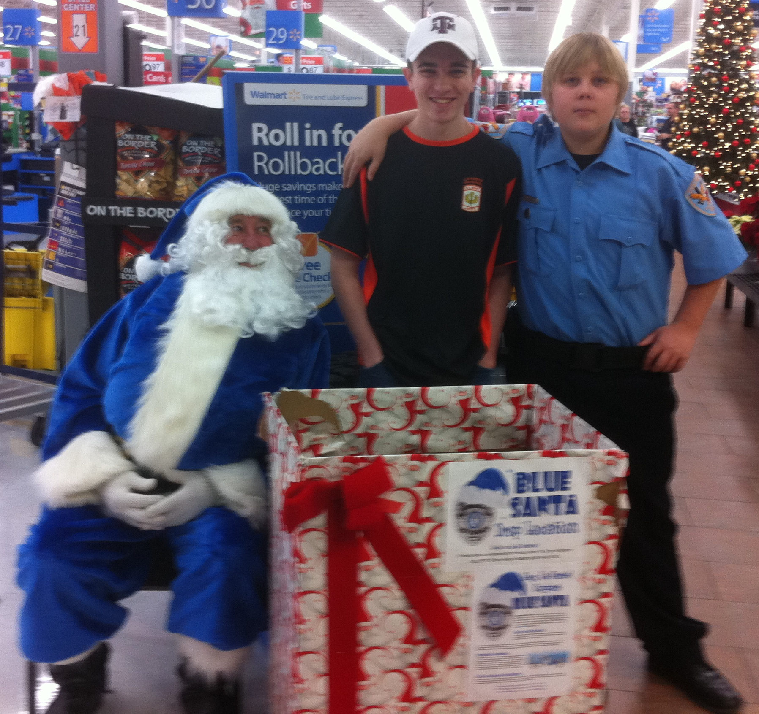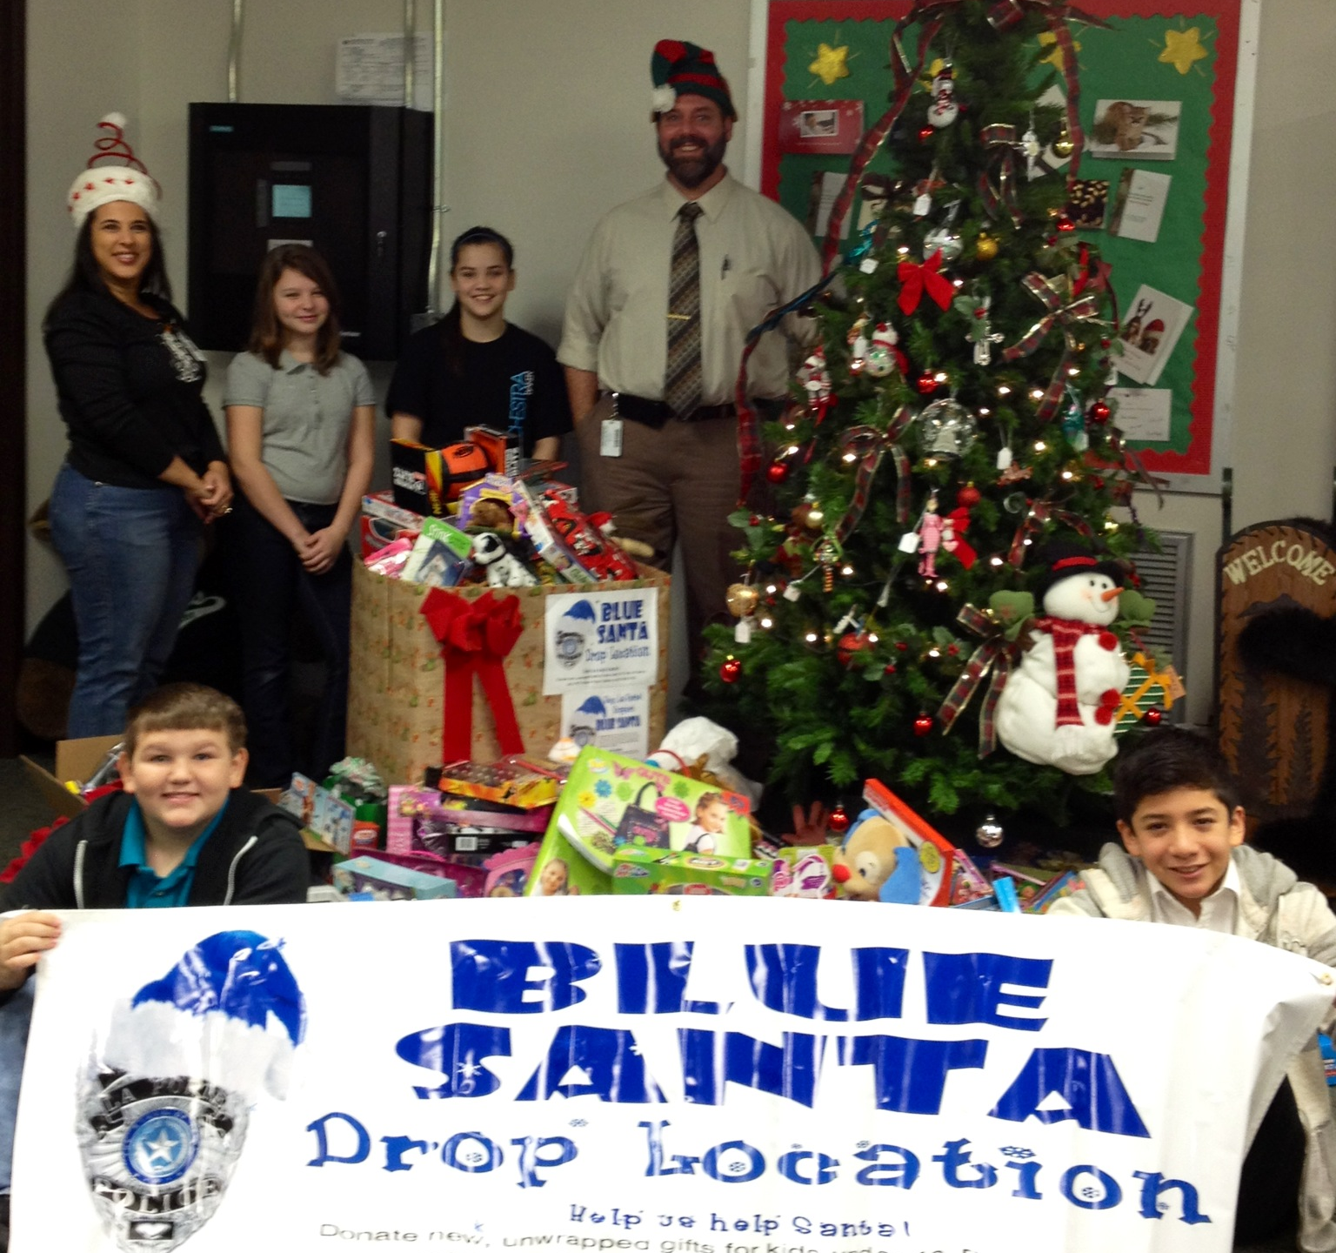
La Porte’s Blue Santa program gift drop-off points were monitored by
Police Youth Explorers as well as LPISD representatives

With the hustle and bustle of the current Christmas and recent Thanksgiving shopping seasons among us, many community members are unaware that there remains a significant portion of our neighbors who may be unable to experience the joy that comes through both the giving and receiving of endearing gifts. Nevertheless, while most people were trying especially hard to avoid the hustle and bustle of Christmas holiday shopping, the participants of the Blue Santa Program took a different approach by starting early and engaging in various fundraising activities within the six-month period preceding the 2011 Christmas season.

The Blue Santa Program represents a collaborative effort between the La Porte Police Department, Citizens Police Academy Alumni Association (LPCPAAA), Municipal Police Officer’s Association, Municipal Court, and Independent School District. The Program’s primary mission is to provide toys and Christmas dinners for needy children and their families in the La Porte area, many of whom would not have the means to hold traditional Christmas festivities on their own.

As a result of the Blue Santa program, over $3000 in donated funds were generated, in addition to dozens of new toys, including some 90 bicycles provided through the Elves and More Program. The cash donations were used to purchase additional toys, all of which were distributed to less fortunate families by La Porte’s Neighborhood Center and the City’s Jennie Riley Community Center. All in all, the group’s efforts touched the lives of over 150 families, allowing hundreds of children to experience the joy of Christmas.

La Porte Police Department stresses that it is through local teamwork, such as the Blue Santa and Elves and More Programs, that we can all make a difference in the lives of those who are less fortunate. For more information on any of La Porte Police Department’s community outreach initiatives, including the CPAAA, Blue Santa, and Elves and More Programs, please contact the Support Services Division at 281-842-3162 or 281-842-3183.

