Media Relations Information for 04/27/2012

BP's “Fabric of America Fund” Makes Donation to LPCPAAA

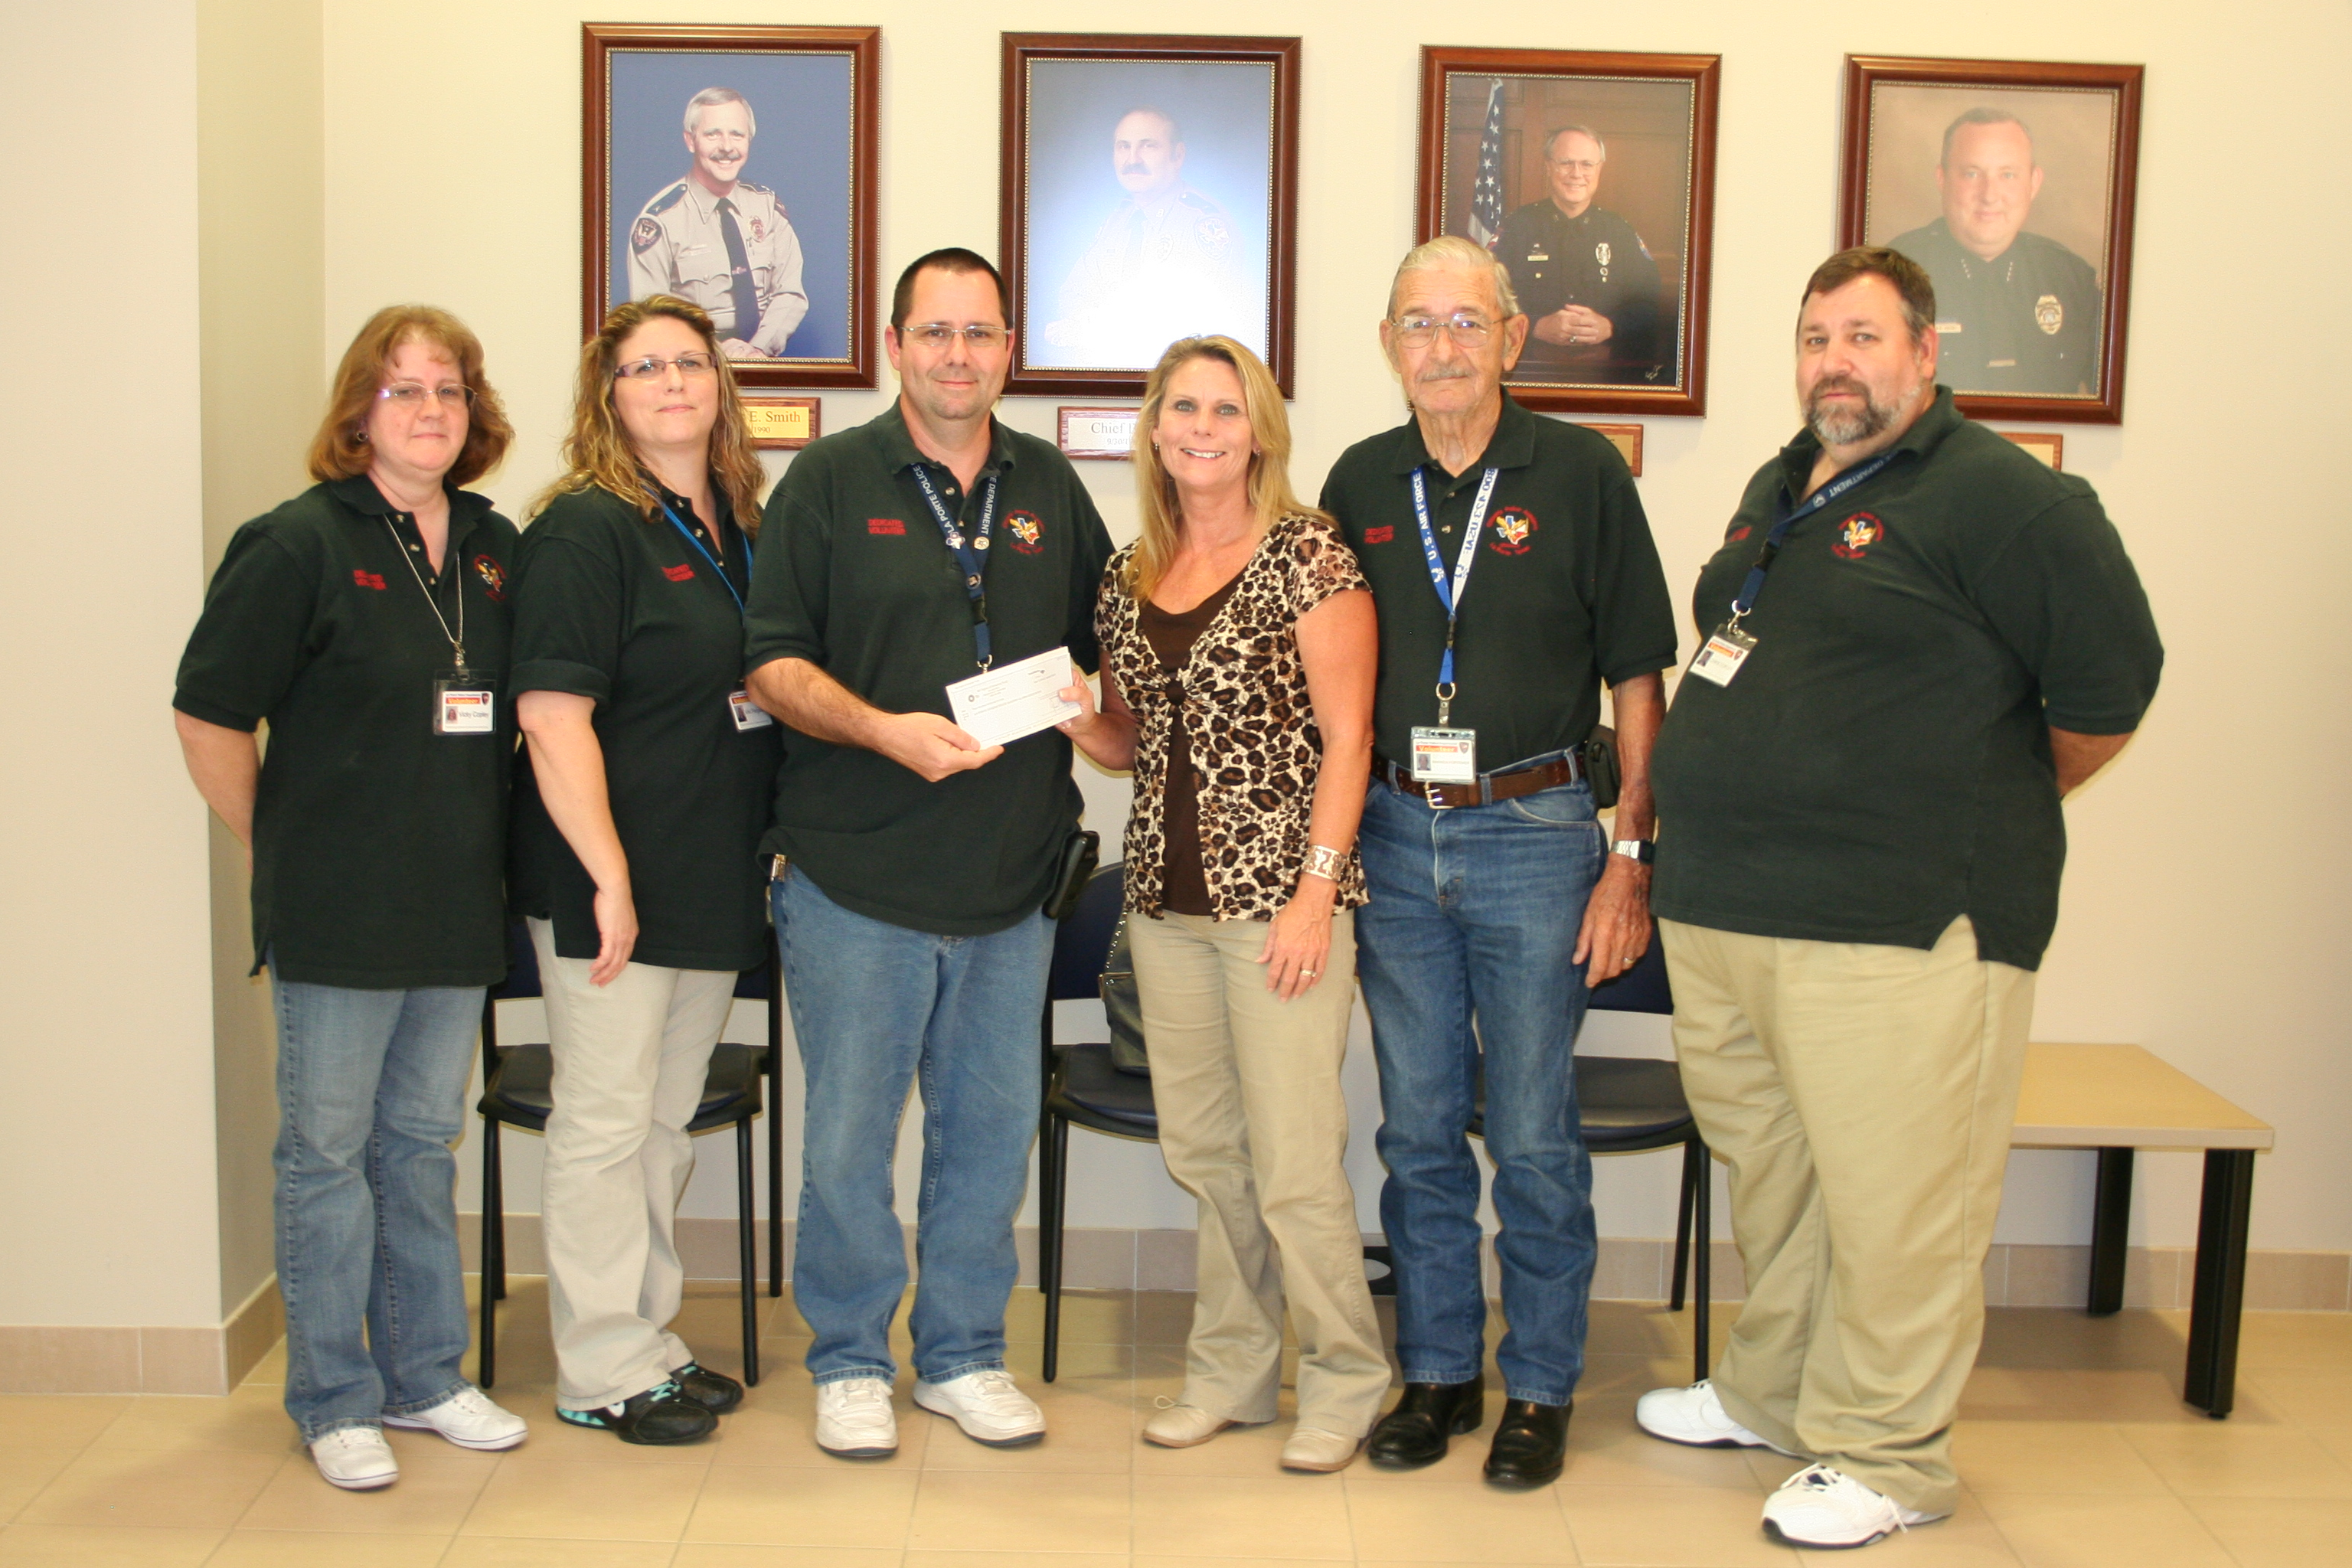
LPCPAAA President Phillip Ferguson and BP-Texas City employee Denise Guerrero (center)
along with LPCPAAA Members (r-l) Vicky Copley, Viki Ferguson, Warren Portenier, Chris Copley
.

BP's Fabric of America Fund provides employees with an opportunity to engage personally and make a difference in their communities through various forms of corporate-sponsored donations. Under the program, BP-Texas City employee Denise Guerrero requested that BP America make a contribution through the fund to the La Porte Citizens Police Academy Alumni Association (LPCPAAA), and her request was readily granted.

The LPCPAAA, a 501(c)3 non- profit organization, is committed to serving law enforcement and the general public by promoting and advancing the Citizens Police Academy. Volunteers actively participate in over 30 different programs throughout the year, including National Night Out, Blue Santa, Sylvan Beach Day and various crime prevention programs.

La Porte Citizens Police Academy Alumni Association President Phillip Ferguson stated, “BP's donation will allow our association to go out and make an even bigger difference throughout community - one project at a time.”

For more information about volunteering with the La Porte Police Department or attending the La Porte Citizen Police Academy, contact Phillip Ferguson at Phillip.Ferguson@att.net or visit the LPCPAAA website at www.LPCPAAA.org.

