Media Relations Information for 03/09/2012
Public Relations Officer – Sgt. John Krueger
Office: 281-842-3161

La Porte Police celebrate another Advanced Citizens Police Academy graduation

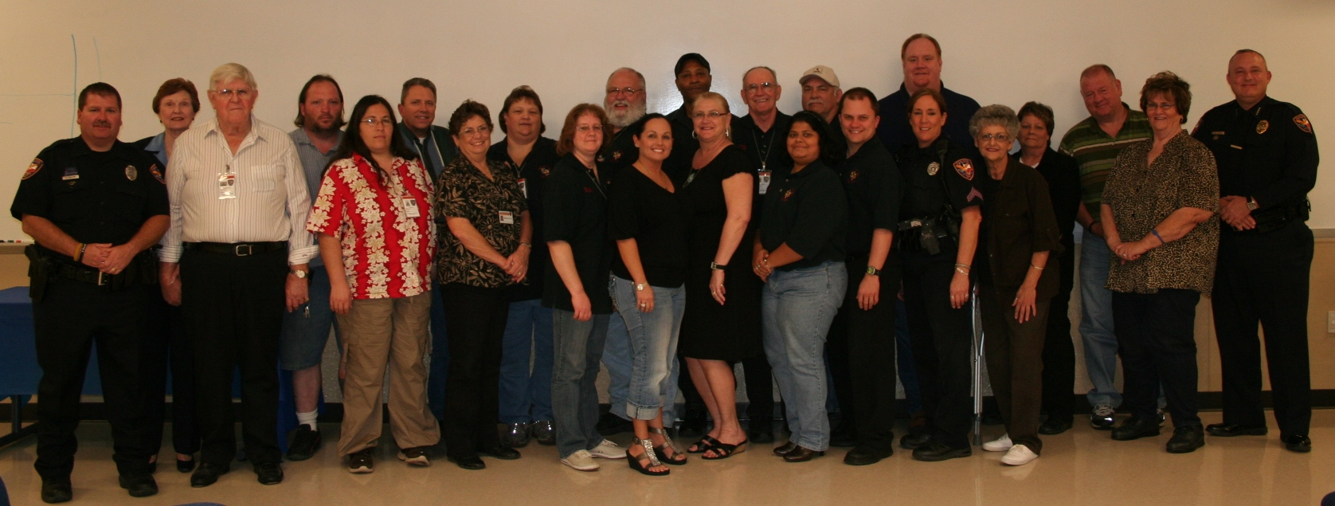

On March 6th, 2012 the La Porte Police Department proudly hosted a graduation ceremony for the most recent members of their Advanced Citizens Police Academy course. The Advanced Citizen Police Academy (ACPA) is a seven-week program designed to provide a working knowledge and background of the La Porte Police Department and foster a closer relationship between police officers and the community they serve. Each of the honored members for the March graduating class were former graduates of the department’s primary Citizens Police Academy (CPA), who elected to enroll in the advanced course in order to seek further, in-depth, information on the operations of the La Porte Police Department. Members of the graduating class included Robert Burkey, Vicky Copley, Lyla DeSouza, Kevin Dorsey, Norma Elliot, Rick Guzman, Felicitas Hernandez, Jose Hernandez, Cheryl Hiser, Ron Honea, David Janda, Dottie Kaminski, Jim Kelley, Elizabeth Lainhart, Ramses Macios, Richard Manning, Emily McDuffie, Karen Rigby, Abe Rosa, Maggie Rosa, Donnice Thompson, Gwen Tilley, Richard Tilley, and Jeanne Zemanek.

The seven-week academy was taught one evening a week with each class lasting three to four hours. The subjects covered during the academy addressed various attributes of emergency operations such as First Responders of LPEMS and LPFD, Special Weapons and Tactics (S.W.A.T.), Crime Scene Processing, Gun Range practices, CPR, Emergency Operations Command, Skywarn System education, and DWI Procedures. Several of these classes also involved field trips with hands-on experience. Graduates of Advance Class “2012 - A” will now have a direct avenue for community involvement and an opportunity to experience policing first hand.

As a highlight of the March 6th ceremony, each graduate received a certificate of completion and the opportunity to join the La Porte Citizen Police Academy Alumni Association. The graduates also maintain eligibility to participate in the police department’s citizen ride along program on a monthly basis.

CPA and Advanced CPA graduates find an abundance of rewarding volunteer opportunities through a series of community service projects & varying station house duties. La Porte Police Chief Ken Adcox was on-hand for the graduation. “Our Department is extremely fortunate to have such a close knit and involved community. It makes all the difference in the world to have a citizen body that is interested, informed, and committed to working with the police to keep our city safe. Such a partnership is a valuable asset, one which we don’t take for granted.” For questions concerning either of La Porte’s Citizens Police Academies, please contact Officer Robyn Gallion at 281-842-3162 or log onto the department’s website at www.ci.la-porte.us/gov/police/support/default.asp.

